

Online Learning Project

**Final Release Document**

– Hanoi, March 2023 –

Contents

I. Deliverable Package 3

II. Installation Guides 3

1> Installing JDK 8u321 3

2> Installing Apache Tomcat 10.0.18 4

3> Installing Apache NetBeans IDE 13. 9

4> Integrating Apache NetBeans IDE 13 with Apache Tomcat. 10

5> Create Java Web project, Servlet and Debug. 13

6> Working with JSTL. 16

III. User Manual 16

1. Overview 16

a. Project 16

2. Tool testing and log bug 17

a. PMD 17

b. Jira 19

c. Issues report: 20

d. Resources. 21

**1.** **Human resources:** 21

**2.** 21

2. System functions: 21

a. Screen flow: 21

b. Screen details: 21

c. Main function of user groups: 26

f. Entity relationship diagram 29

IV. Functional requirements 29

1. Public feature 29

a. Home page: 29

b. Pop-up: 32

2. Common feature: 32

a. Sign up: 32

b. Fill information: 33

c. Verify register: 34

d. Sign in: 34

e.Class: 35

f. Course: 36

g. Chapter: 37

h. Module: 38

i. Lession: 38

j. Quiz: 39

k. Video lession: 42

l. Games: 42

m. Payment: 43

n. Confirm payment: 44

o. Email payment: 45

p. User profile: 45

q. Change user profile: 46

r. Change password: 46

s. Ranking: 47

3. Admin feature: 48

a. Manage quiz: 48

b. Manage games: 50

c. Manage video lession: 52

d. Manage content: 52

e. Manage user: 53

f. Add/modify chapter: 55

g. Add/modify lession: 55

# I. Deliverable Package

| **No.** | **File** | **Notes** |
| --- | --- | --- |
| 1 | Group2_DB_final.sql | Database, including both table structures and table data |
| 2 | Group2 _SRS_final.docx | Final SRS (Requirement) Document |
| 3 | Group2 _SDS_final.docx | Final SDS (Design) Document |
| 4 | Group2_Final Project tracking.xlsx | Final status for the application functions, which include:  - Function name, feature, roles, function description (changes compared to the original requirements are highlighted)  - In Charge, Planned iteration & Actual iteration  - Final status & note on the update you made |
| 5 | Group2_IssuesReport.xlsx | Final issues tracking list of the whole project |
| 6 | Source project | Link git hub: <https://github.com/hoanglhhe161738/SWP391-OnlineLearn> . |

# II. Installation Guides

## 1> Installing JDK 8u321

Page:

Scroll down to find the version you need.

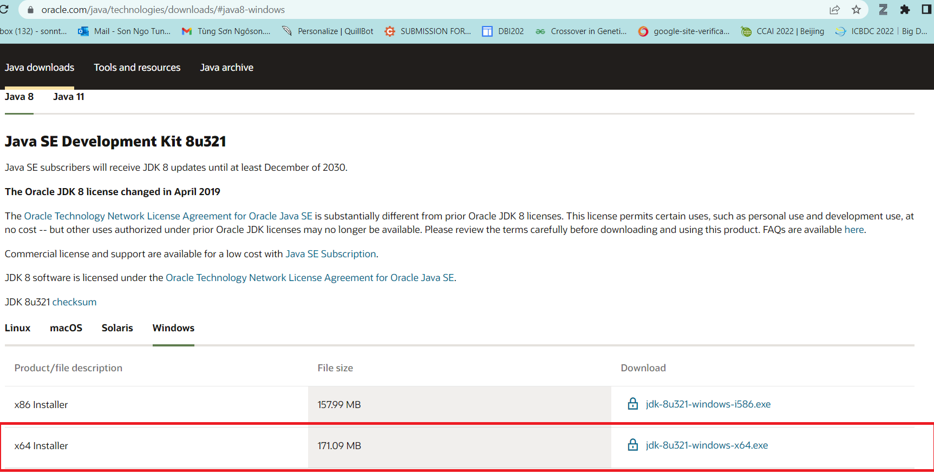

After installing, let check the installation folder:

Normally it will be located at: C:\Program Files\Java. It contains 2 folders JDK and JRE.

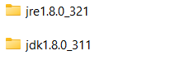

If you see these folders, it is ok for now.

For more details, you can read <https://www.oracle.com/java/technologies/javase-jdk8-doc-downloads.html>

## 2> Installing Apache Tomcat [10.0.18](https://tomcat.apache.org/download-10.cgi#10.0.18)

Download page: <https://tomcat.apache.org/download-10.cgi>

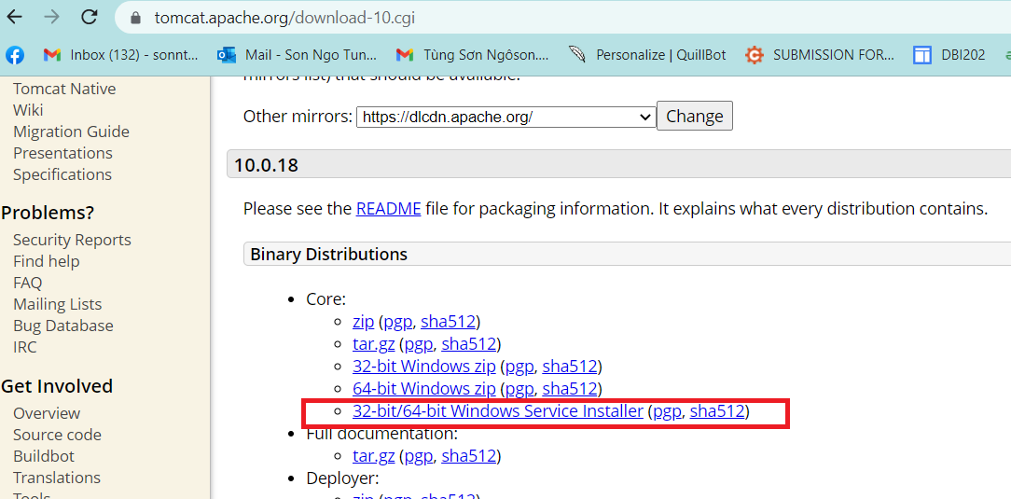

Open the installer file then click “Next” button, until you see the below screen:

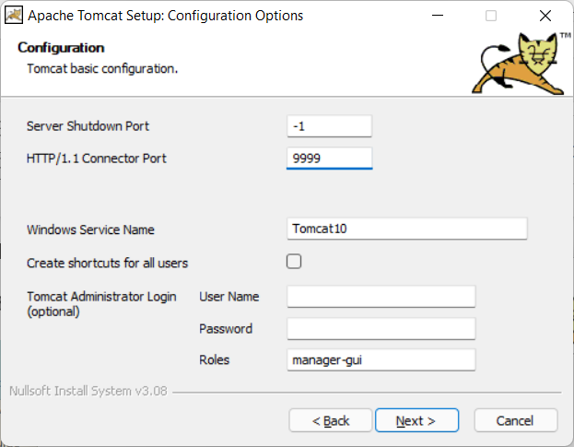

By default, the HTTP port is set as 8080, but I prefer to change it to 9999. You can keep it as 8080 or change it as you desire. Same for Window Service Name.

You can also set username and password at this step, but it is an optional and you can do it later.

Click “Next”, then the installer will ask you for JRE folder. Basically, the installer can automatically detect JRE folder, but in the case it cannot, you can add it manually.

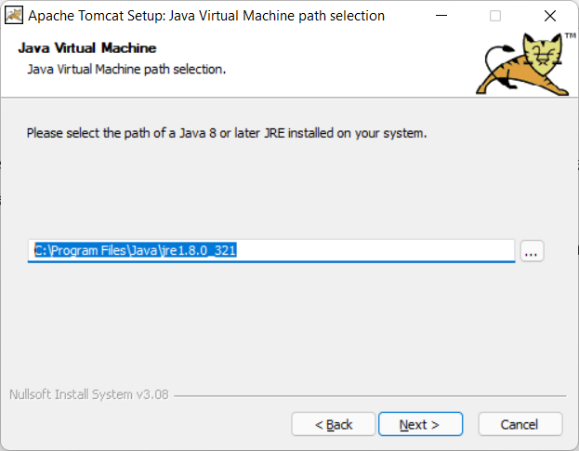

Click “Next” …. Again then “Finish”.

Normally, you are going to see the below window app displayed:

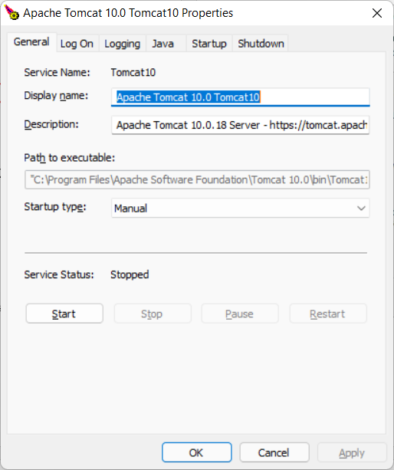

It is ok, this application used to control your TOMCAT webserver, but if you do not see it, do not worry. I recommend you follow below instructions:

1. TOMCAT now is installed as a Window Service (It is a software, but it does not have a graphic user interface).
2. To work with Window Service, press windowR, fill service.msc

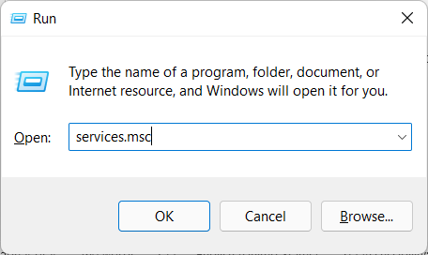

1. Find the TOMCAT service in the list:

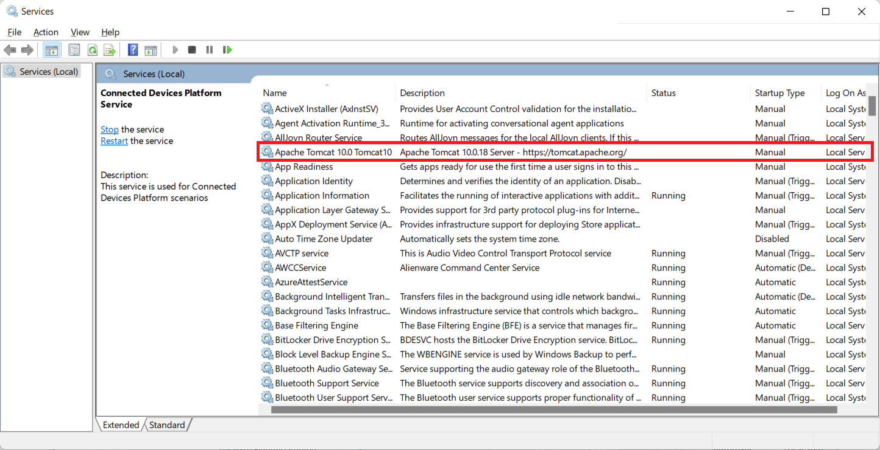

Right click -> properties ->

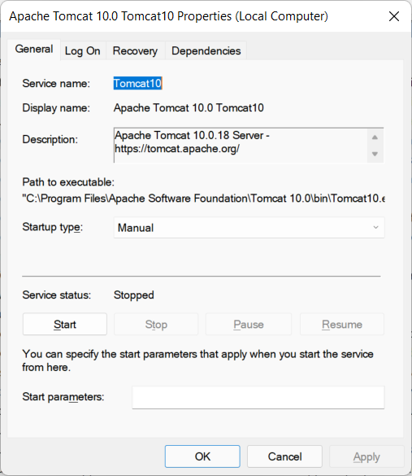

Now you can start/stop the TOMCAT service. Just make sure it is running before use.

You can grant permission for TOMCAT to run with Local System account on the same dialog.

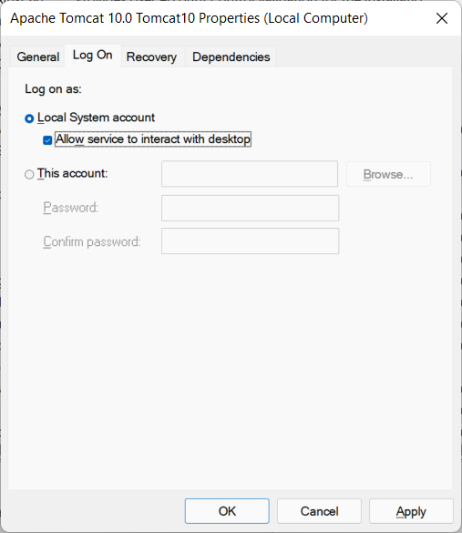

## 3> Installing Apache NetBeans IDE 13.

Download: <https://netbeans.apache.org/download/nb13/nb13.html>

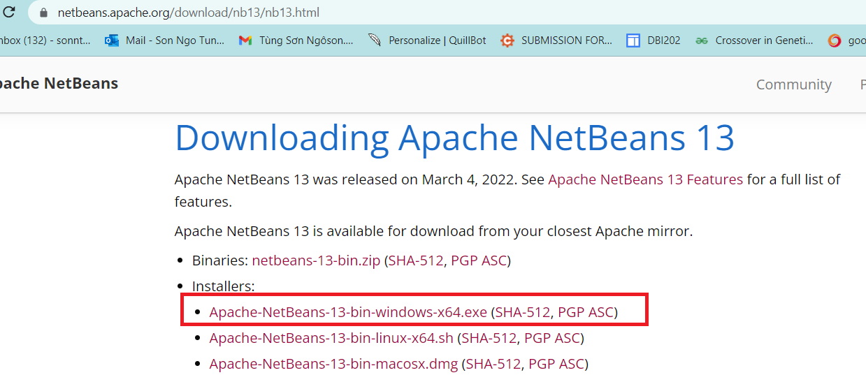

During your installation, remember to select JDK 1.8 (just in case, you have more than one version of Java).

After installation, run netbeans 13, File > New Project > Java with Ant > Select Web Application (It is disabled by default, just select it, netbeans will automatically enable the project template).

## 4> Integrating Apache NetBeans IDE 13 with Apache Tomcat.

First, open the Apache Tomcat folder:

By default, it is located at: C:\Program Files\Apache Software Foundation\Tomcat 10.0

The system may ask you to grant permission, just click “Yes” button. This step aims to allows your account to access the Apache Tomcat folder for further tasks.

Open netbeans, on the menu bar, Window > Service (ctrl 5) > select Service panel as following:

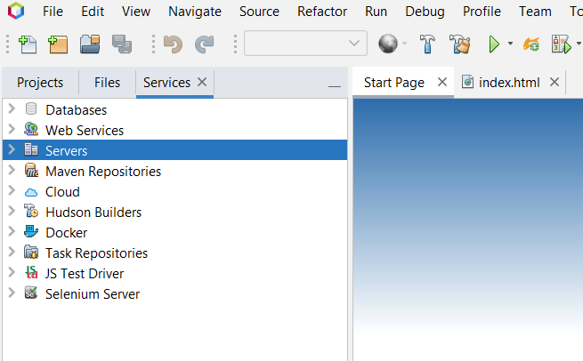

Server > Right click > Add Server > Apache Tomcat and TomEE >

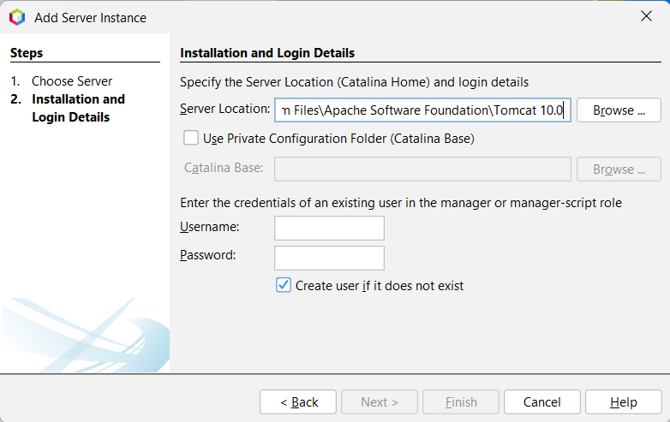

Here you can create your username and password, then finish. Now you can work with Java Web project in netbeans 13.

If you get an error related to “CATALINA_base is Invalid”, check the first step.

Errors related to Tomcat will be logged to “C:\Program Files\Apache Software Foundation\Tomcat 10.0\logs”, check the catalina**** file for the detail logs.

## 

## 5> Create Java Web project, Servlet and Debug.

To create a new java web project: File > New Project > Java with Ant> Java Web > Web Application (See the below figure)

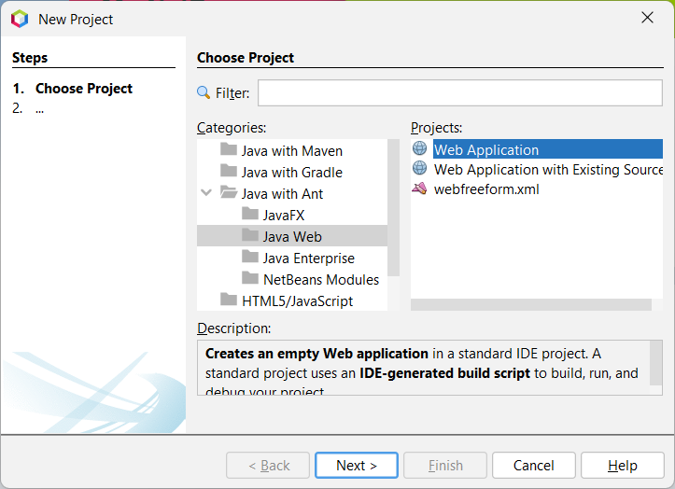

/// LET DO IT, IN THE SESSION OF SERVLET

Once you create new Servlet via Netbeans template file. By default, netbeans using javax, which is not included in Jarkata EE platform equipped by Tomcat 10. Just need to replace all javax by Jakarta package, then everything will be compiled.

|  |  |
| --- | --- |
|  |  |

Refer to <https://tomcat.apache.org/> for more detail

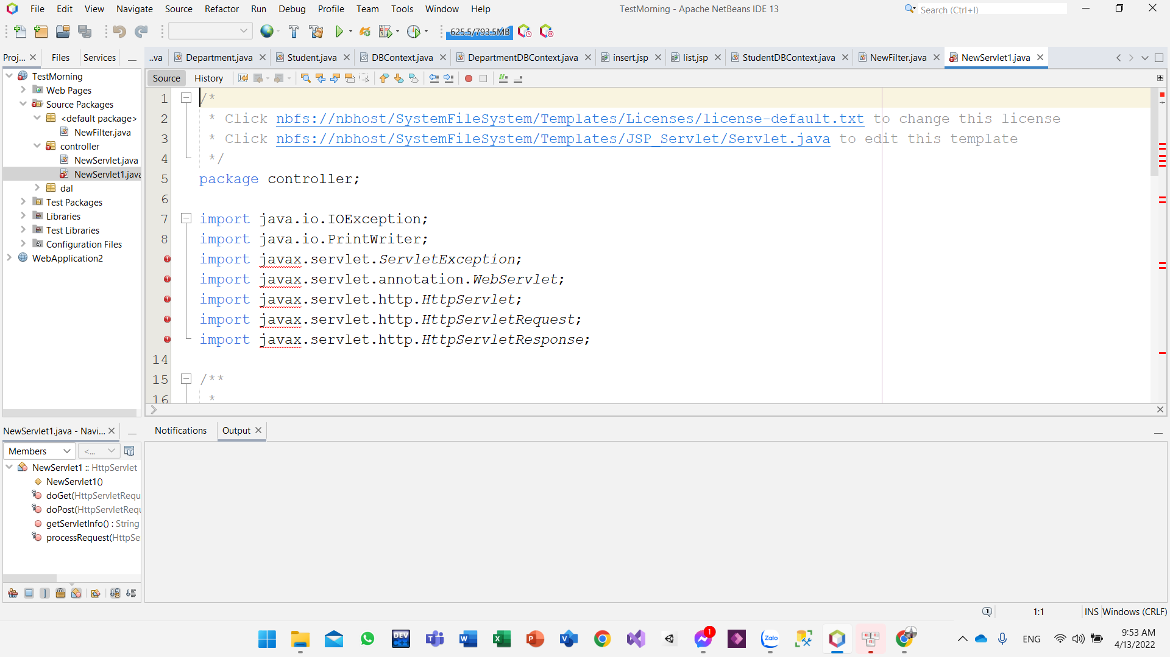

you can also edit the template file for further tasks.

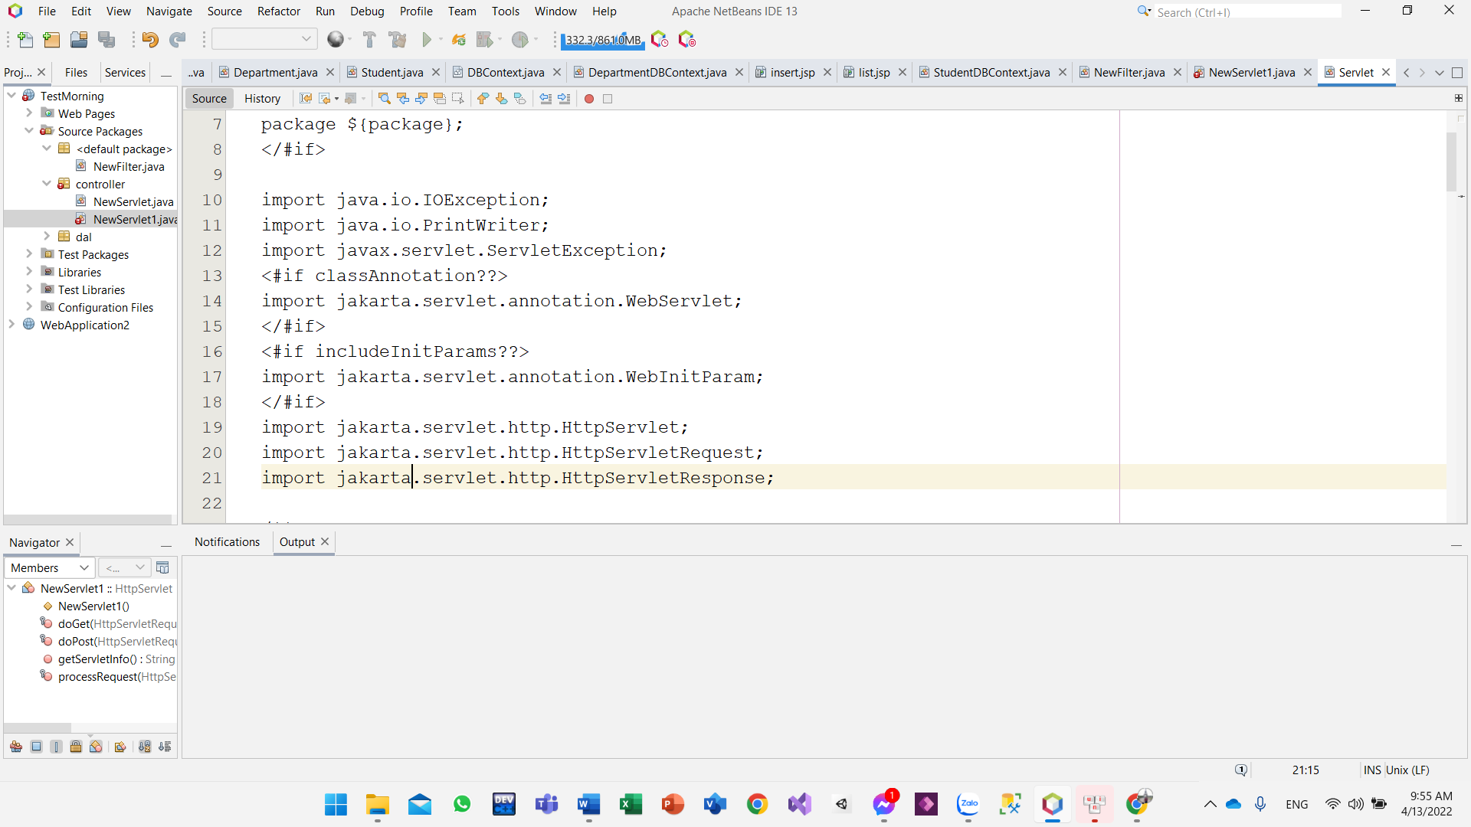

**//** For one who cannot start debugging mode with apache tomcat 10. Open task manager window then kill the process of Java SE.

Check the video: <https://youtu.be/9Zcy7yWNAm4>

OR

Open window PowerShell, type command:

get-process

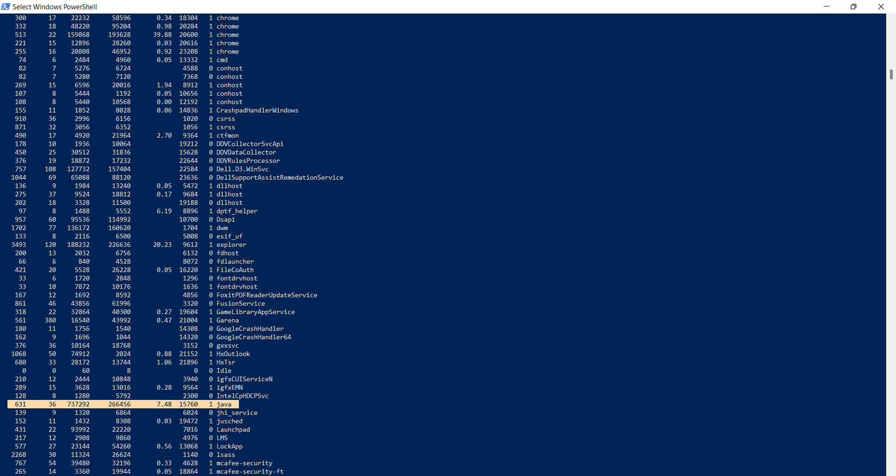

Find java-se process id, then type command:

taskkill /pid 15760 /F

Now you can try debugging again with NetBeans and tomcat.

## 6> Working with JSTL.

Latest version of JSTL build on J2EE was 1.2x. Since the Tomcat 10 is using Jakartified version (with jakarta.* package instead of javax.* package), use JSTL 2.0 to solve this dependency:

Download: Jakarta Standard Tag Library API

Link: <https://search.maven.org/artifact/jakarta.servlet.jsp.jstl/jakarta.servlet.jsp.jstl-api/2.0.0/jar>

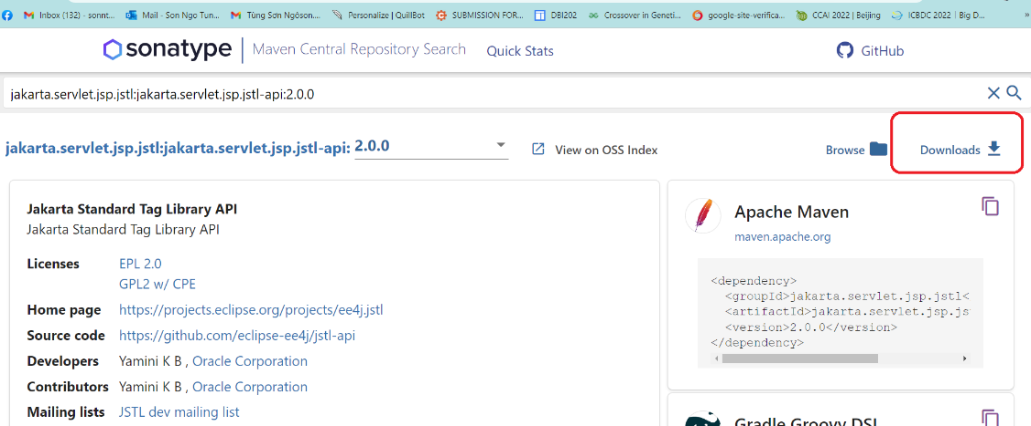

Download: Jakarta Standard Tag Library Implementation

Link: <https://search.maven.org/artifact/org.glassfish.web/jakarta.servlet.jsp.jstl/2.0.0/jar>

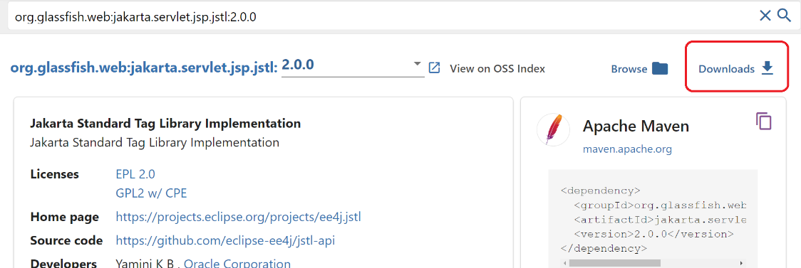

Check the document here:

<https://jakarta.ee/specifications/tags/2.0/jakarta-tags-spec-2.0.html>

# III. User Manual

## Overview

a.Team member:

|  |  |  |
| --- | --- | --- |
| **Member** | **Student ID** | **Task** |
| Ly Hai Hoang | HE161738 | Database designer, Front-end developer |
| Nguyen Quoc Khanh | HE161833 | Database designer, Back-end developer |
| Nguyen Luong Khang | He161660 | Database designer, Back-end developer, designer ui-ux |
| Phan Trung Kien | HE161863 | Back-end developer |
| Phan Manh Thang | HE163595 | Documentation |

1. Project

* Introduction project:

This project is aimed at Online Learning system which supports for students and parents finding the most suitable course which are maths, literature, English, etc. All of this course is very easy to use and learn, it has learning-game so the students find it interesting to learn.

* Project overview:

|  |  |  |  |  |  |
| --- | --- | --- | --- | --- | --- |
| Project overview | | | | | |
|  | | | | | |
| Project information |  | | | | |
|  | | | | | |
| Project name | SWP391_OnlineLearn_Group2_SE1643 | | | | |
| Name of product | Vui học | | | | |
| Product description | The web to learning online | | | | |
| Project description | - Project wil create web to learning online for the student of grade 1-5. Ensure the website is released without defects.  - Output product: Vui học Website. | | | | |
| Project type | | Testing/ product development | | |
| Project duration | Start date: | 1/4/2023 | | Release date: | 3/22/2023 |

## 2. Tool testing and log bug

1. PMD

- After using PMD on project:

The number of bug: 137

**The number of type of bug: 9 types of bug include**

* ClassNamingConventions (1 bug)
* Describe: Class names should begin with an uppercase character.
* MethodNamingConventions (38 bug).
* Describe: Method names should not start with capital letters.
* VariableNamingConventions (18 bug)
* Describe: variables that are not final should not contain underscores (except for underscores in standard prefix/suffix).
* ShortVariable (4 bug)
* Describe: Avoid variables with short name like md, sb, md, no.
* UncommentedEmptyConstructor (7 bug)
* Describe: Document empty constructor.
* UseStringBufferForStringAppends (1 bug)
* Describe: Prefer StringBuffer over = for concatenating strings.
* LocalVariableCouldBeFinal (7 bug)
* Describe: Local variable could be declared final.
* LongVariable (3 bug)
* Describe: Avoid excessively long variable names like parent_phone_number.
* MethodArgumentCoundBeFinal ( 58 bug)

Describe: Parameter is not assigned and could be declare final.

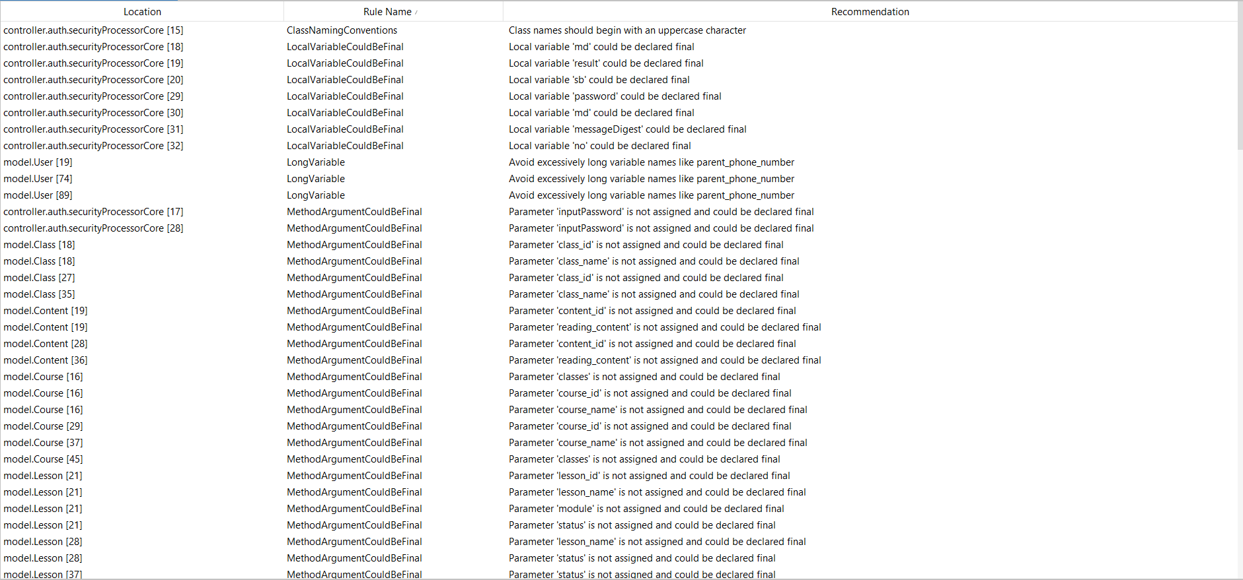

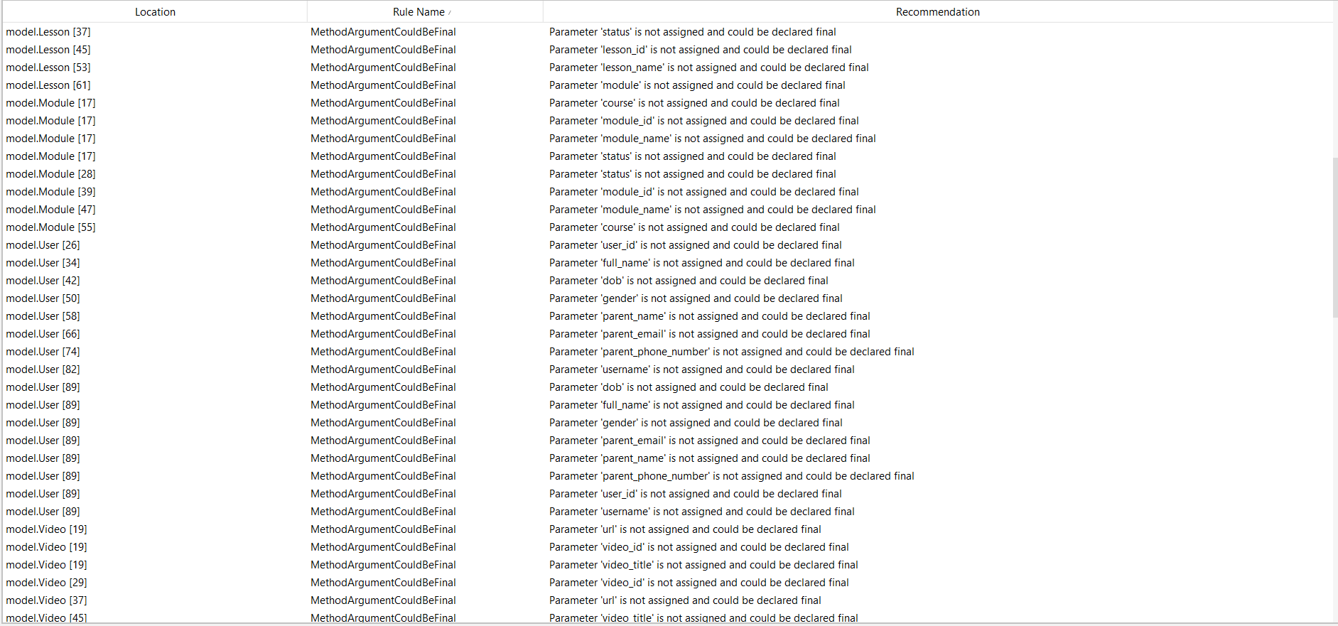

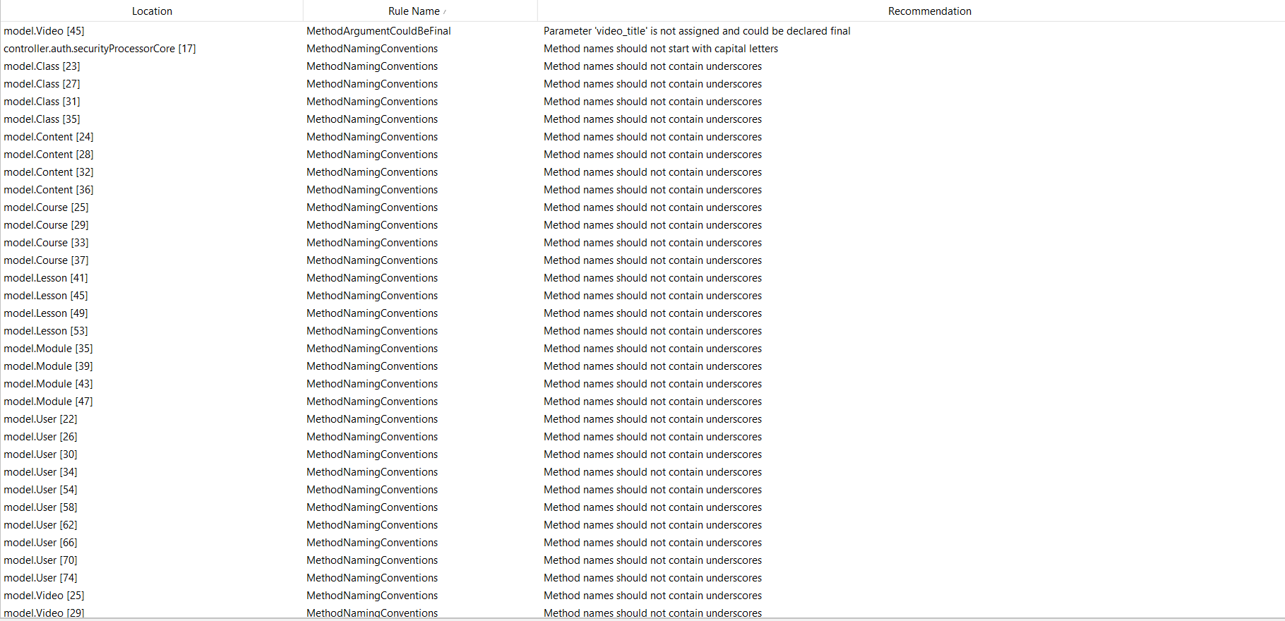

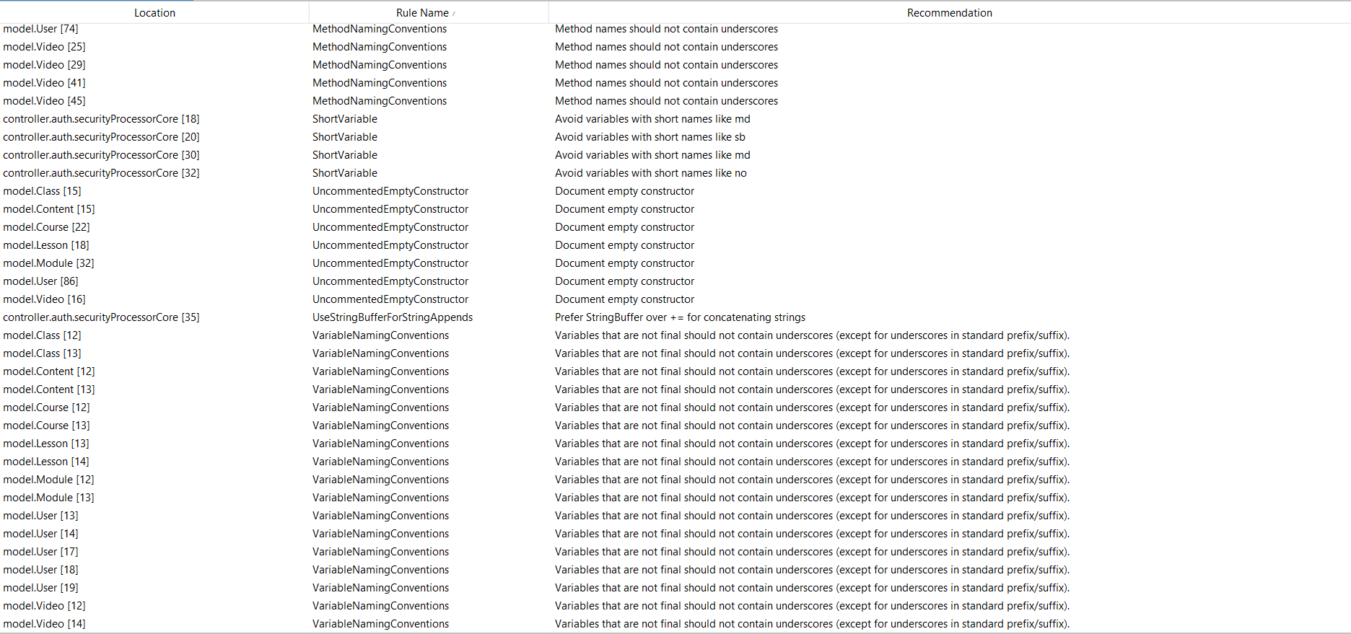

1. Jira

Jira log bug:

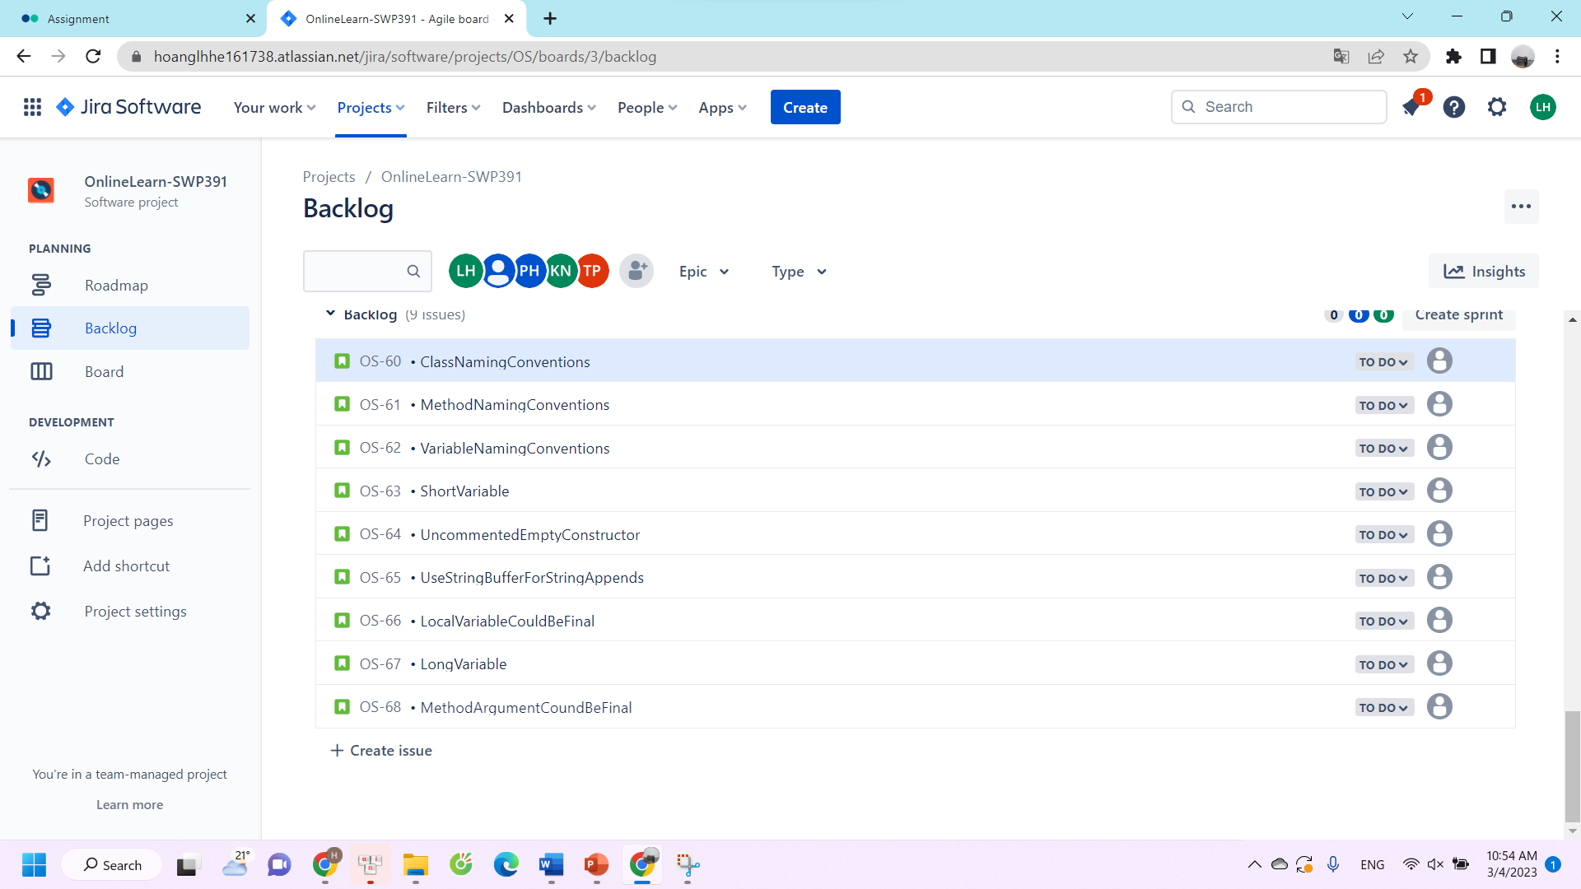

1. Issues report:

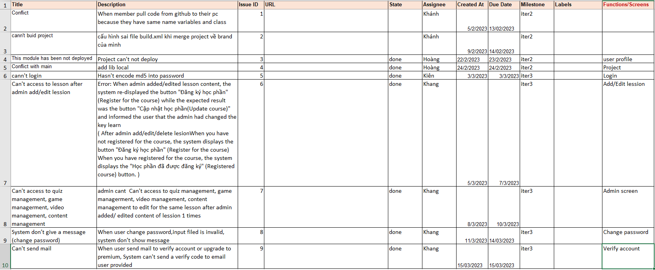

## 2. System functions:

### a. Screen flow:

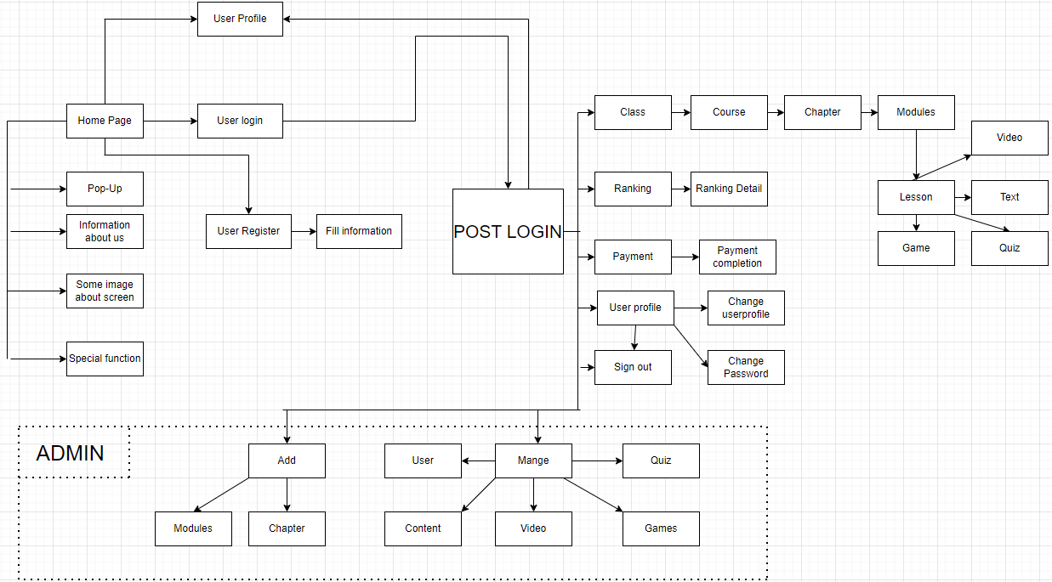

### b. Screen details:

|  |  |  |  |
| --- | --- | --- | --- |
| **#** | **Feature** | **Screen** | **Description** |
| 1 | Public | Home Page | - Show navigation bar: Home, class, ranking, payment, user profile.  - Show information of web which includes main functions: Learning with quiz, learning with playing games and learning with video.  - Show importance of learning online.  - Show main screen when user learn.  - Show information about team who develop this learning web.  - Show information to contact with our team. |
| 2 | Public | Pop-Up | - Show the notification to user. |
| 3 | Public | Register | - Show navigation bar: Home, class, ranking, payment, profile.  - User need to fill username, password and confirm password valid to sign up account. |
| 4 | Common | Fill information | - Show navigation bar: Home, class, ranking, payment, profile.  - User need to fill information which include: Full name, date of birth, gender, parent’s name, parent’s gmail, phone number to verify. |
| 5 | Common | Verify register | - User receive number code in email and fill the code to verify account.  - The code will invalid after 2 minutes. |
|  | Common | Register successful | - Show notify that user have registered successful and press to home page. |
| 6 | Common | Sign in | - Show navigation bar: Home, class, ranking, payment, profile.  - User need to fill their username and password to access their account. |
| 7 | Common | Sign in complete | - Show notify that user access account successfully and press to home page. |
| 8 | Common | Class | - Show navigation bar: Home, class, ranking, payment, profile.  - Show all of the class from grade 1 to grade 5.  - User can choose the suitable class that they want to learn. |
| 9 | Common | Course | - Show navigation bar: Home, class, ranking, payment, profile.  - Show all of the course of the class (maths, literature, english).  - User can choose one of three subjects to learn. |
| 10 | Common | Chapter | - Show navigation bar: Home, class, ranking, payment, profile.  - Show all chapter of subject that user can choose to learn.  - Show percent of learning of subject. |
| 11 | Common | Module | - Show navigation bar: Home, class, ranking, payment, profile.  - Show all module of chapter of subject that user can choose to learn.  - Show percent of learning this chapter of subject. |
| 12 | Common | Lesson | - Show navigation bar: Home, class, ranking, payment, profile.  - Show all of lesson which include: Exercises, game, video, theory. |
| 13 | Common | Quiz | - Show navigation bar: Home, class, ranking, payment, profile.  - User can press to start excercises.  - User need to read and follow the rules of this excercises.  - User need to answer all of the questions to finish the excercises.  - User can re-do excercises.  - After doing quiz, user receive their point. |
| 14 | Common | Video | - Show navigation bar: Home, class, ranking, payment, profile.  - Show video that user can watch to learn. After watching video, user can do excercises and play game. |
| 15 | Common | Ranking | - Show navigation bar: Home, class, ranking, payment, profile.  - Show ranking point, index.  - User can search by name to find their ranking and point. |
| 16 | Common | Games | - Show navigation bar: Home, class, ranking, payment, profile.  - Press start to start playing game.  - Click image to right image to have point.  - After 100 second, the game will finish and caculate pointn you have. |
| 17 | Common | Payment | - Show navigation bar: Home, class, ranking, payment, profile.  - Show transaction of user to pay for premium account which include visa, credit card, paypal.  - User need to fill the right number of their card.  - Show the advantages of premium account.  - Show the total price of premium account per year and VAT |
| 18 | Common | Confirm payment | - This screen notifies to user to enter code which have 6 numbers. The code is in their email that we sent to.  -User need to fill the code in 2 minutes or the code will be expired. |
| 19 | Common | Email payment | - This screen notifies to user that user have to fill email to confirm to pay  -User need to fill their email address and click to send code to pay |
| 20 | Common | Payment success | - Notify to user that payment success and upgrade to premium. |
| 21 | Common | Fail payment | - This screen notifies to user that user have failed to pay.  -User can choose try again or cancel |
| 22 | Common | User profile | - Show navigation bar: Home, class, ranking, payment, profile.  - Show all information about user which include: Full name, date of birth, gender, parent’s name, parent’s email, phone number, user id, type of account. |
| 23 | Common | Change user profile | - Show navigation bar: Home, class, ranking, payment, profile.  - User can change information which include: Full name, gender, date of birth, parent’s name, parent’s email, phone number, user id, type of account.  - User press save to save new information. |
| 24 | Common | Change pasword | - Show form which include old password, new password, confirm new password.  - User need to fill valid password. |
| 25 | Admin | Manage quiz | - Show form which admin choose class, course, chapter, lession that admin want to add or delete quiz.  - After fill the form, admin press “Hoàn Tất” to add quiz.  - After choose question, admin press “Xác nhận và xóa” to delete quiz. |
| 26 | Admin | Manage games | - Show form which admin choose class, course, chapter, lession that admin want to add pictures for game.  - After fill the form, admin press “Hoàn tất” to add pictures. |
| 27 | Admin | Manage video | - Show form which admin choose class, course, chapter, lession that admin want to add video lession.  - After fill the form, admin press “Hoàn tất” to add video lession. |
| 28 | Admin | Manage content | - Show form which admin choose class, course, chapter, lession that admin want to add/edit content.  - After fill the form, admin press “Hoàn tất” to add content or edit content. |
| 29 | Admin | Manage user | - Show total account which include normal account and premium account.  - Show list of account information which include: Full name, date of birth, gender, parent’s full name, parent’s email, parent’s phone number and usernamme.  - Admin can search by name account. |
| 30 | Admin | Add/modify chapter | - Show form which admin choose class, course, chapter that admin want to add or modify chapter.  - After fill the form, admin press “Hoàn tất” to add or modify chapter. |
| 31 | Admin | Add/modify module | - Show form which admin choose class, course, chapter that admin want to add or modify module. - After fill the form, admin press “Hoàn tất” to add or modify module. |

### c. Main function of user groups:

- Guest:

* Home Page
* Sign up
* Fill information
* Verify register

- Customer:

* Login
* Log out
* View class
* View course
* View chapter
* View module
* View lession
* Do quiz
* Watch video lession
* Play learning games
* Theory
* View ranking
* Payment
* Confirm payment
* User profile
* Change user profile
* Change password

- Admin:

* Mange quiz
* Add/delete quiz
* Mange games
* Add/delete image
* Manage video
* Add/delete video
* Mange content
* Add/delete content
* Manage user
* View current user
* Add/modify chapter
* Add/delete chapter
* Add/modify lession
* Add/delete lession

#### d. User Authorization

|  |  |  |  |  |
| --- | --- | --- | --- | --- |
| Screen | Guest | Normal User | Premium User | Admin |
| Home page | X | X | X |  |
| Pop-Up | X | X | X | X |
| Sign up | X | X | X |  |
| Fill information | X | X | X |  |
| Verify register | X | X | X |  |
| Login |  | X | X | X |
| Class |  | X | X | X |
| Course |  | X | X | X |
| Chapter |  | X | X | X |
| Module |  | X | X | X |
| Lesson |  | X | X | X |
| Quiz |  | X | X | X |
| Video lession |  | X | X | X |
| Theory lession |  | X | X | X |
| Games |  |  | X | X |
| Payment |  | X | X | X |
| Confirm payment |  | X | X | X |
| Email payment |  | X | X | X |
| Payment success |  | X | X | X |
| Fail payment |  | X | X | X |
| User profile |  | X | X |  |
| Change user profile |  | X | X |  |
| Change password |  | X | X |  |
| Ranking |  |  | X | X |
| Manage quiz |  |  |  | X |
| Manage games |  |  |  | X |
| Manage video lession |  |  |  | X |
| Manage content |  |  |  | X |
| Manage user |  |  |  | X |
| Add/modify chapter |  |  |  | X |
| Add/modify lession |  |  |  | X |

In which:

- Admin: the organization leader/manager, acts as the system administrator. Admin manage quiz, games, video lession, content, user and add or modify chapter, lession. Admin can join web by role as user.

- Customer: + Parents: They are registered users who find the system, choose and register for their childrens.They also the person who pay for premium account.

+ Students: They are users who experience the system. Students can learn any course, do quiz, watch video lession. If their account are upgraded to premium account, they can view ranking and play games.This is potiental user.

- Guest: Unregistered users who can view home page.

#### e. Non-Screen Functions

|  |  |  |  |
| --- | --- | --- | --- |
| **#** | **Feature** | **System Function** | **Description** |
| 1 | Common | User Authentication | Implementation of authorization mechanism in the system, including the specify the role of logged-in user, his/her authorized page links (building the displayed menu items (in the front end) and preventing unauthorized access via enter the links directly). |
| 2 | Common | Usability | It is easy to use for childrens because all object’s name same with the function this object do. |

## f. Entity relationship diagram

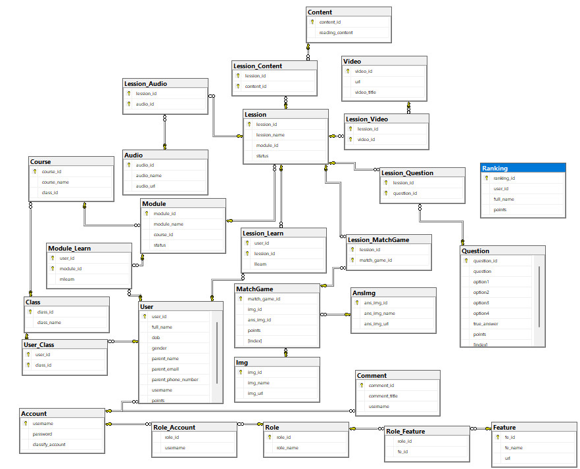

# IV. Functional requirements

## 1. Public feature

### a. Home page:

* Function trigger: Direct access via link .
* Function description:
  + User roles will have access to this screen.
  + Show navigation bar: Home, class, ranking, payment, user profile.
  + Show information of web which includes main functions: Learning with quiz, learning with playing games and learning with video.
  + Show importance of learning online.
  + Show main screen when user learn.
  + Show information about team who develop this learning web.
  + Show information to contact with our team.

Screen layout:

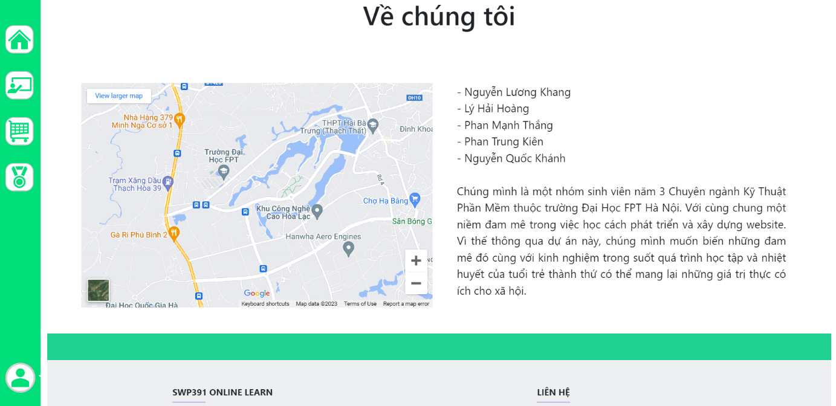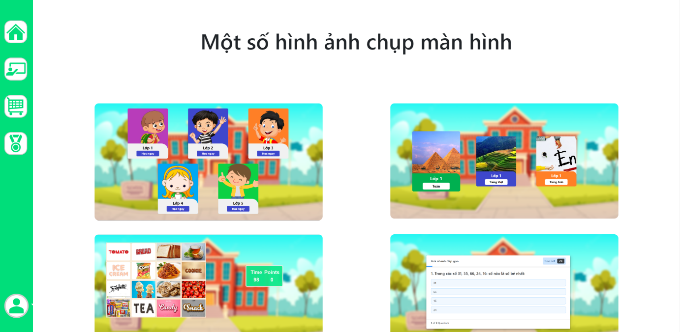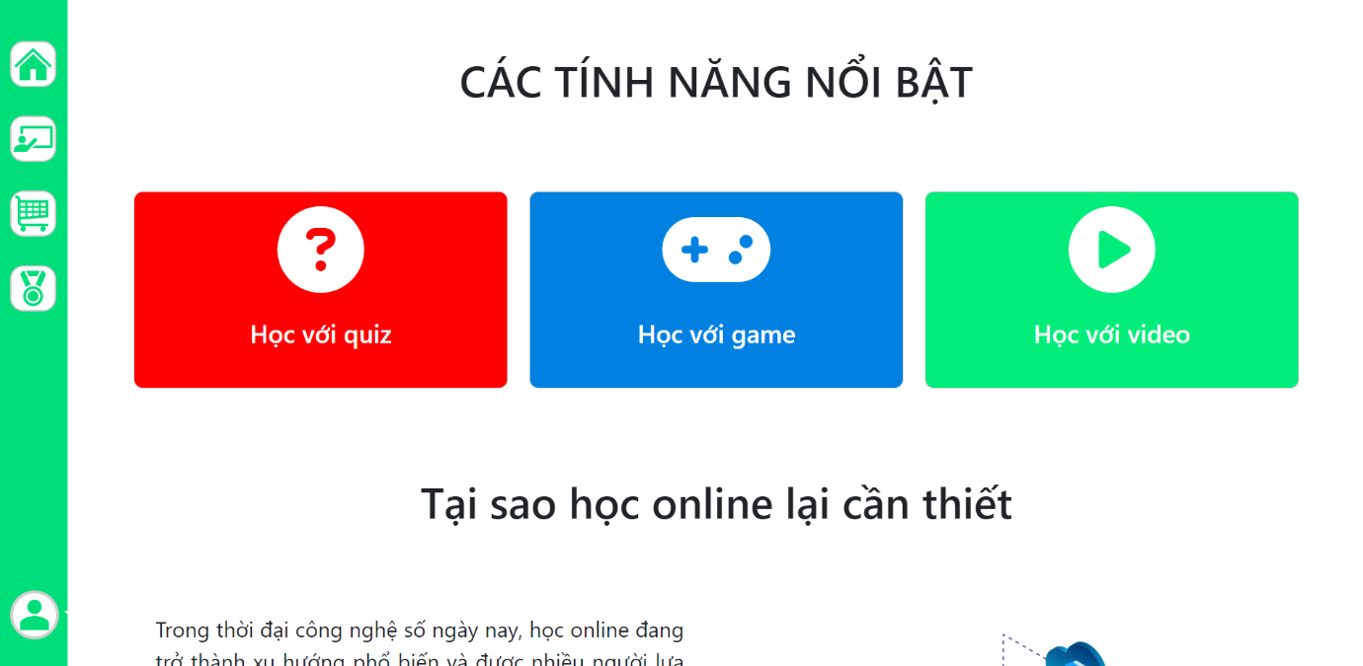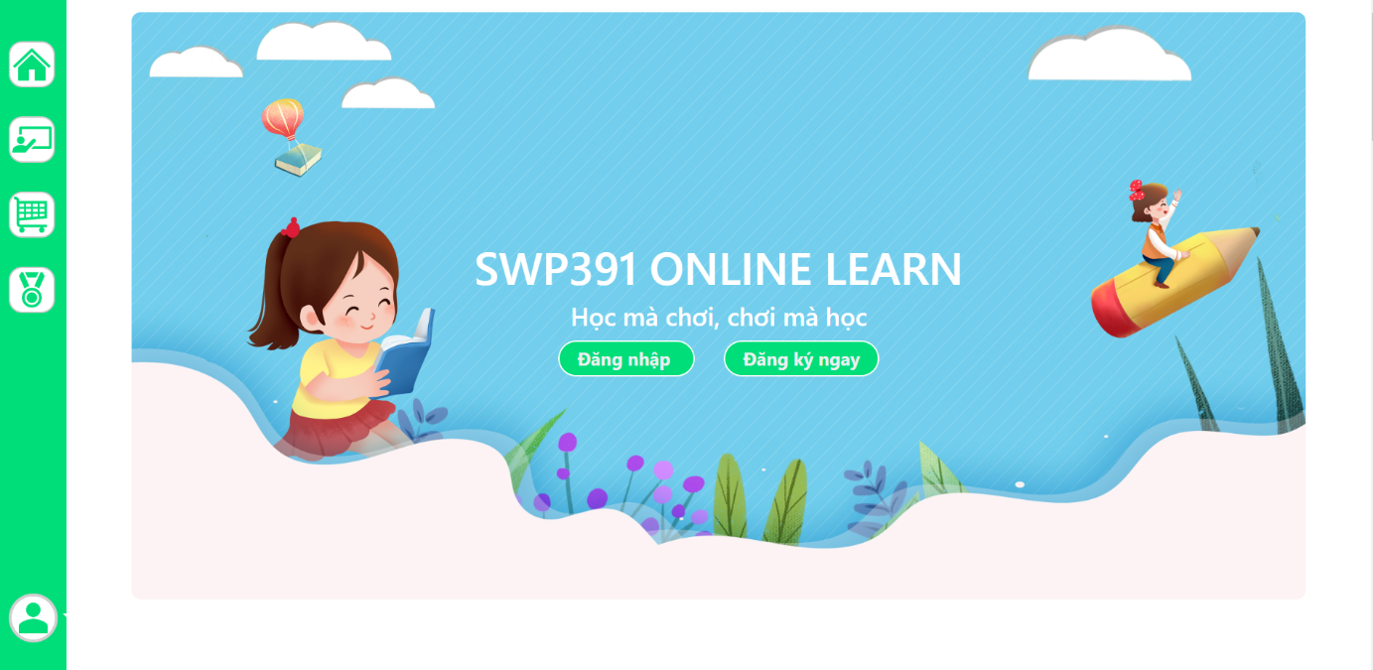

### b. Pop-up:

* Function trigger: Automation appear when user go to Home Page.
* Function description:

- Customer roles will have access to this screen.

- This screen show the important notification to user.

Screen layout:

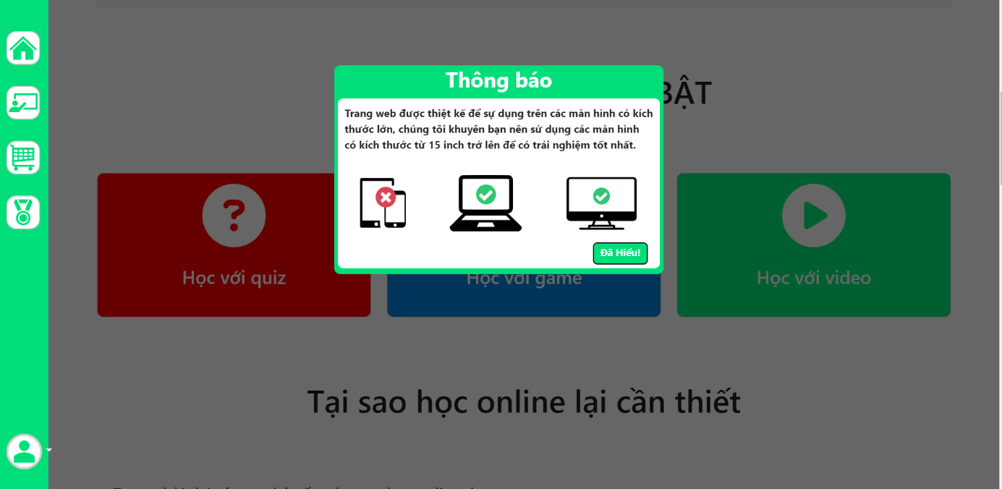

## 2. Common feature:

### a. Sign up:

* Function trigger: When user click “Đăng kí ” at home page.
* Function description:

- Customer roles will have access to this screen.

- Show navigation bar: Home, class, ranking, payment, profile.

- User need to fill username, password and confirm password valid to sign up account.

Screen layout:

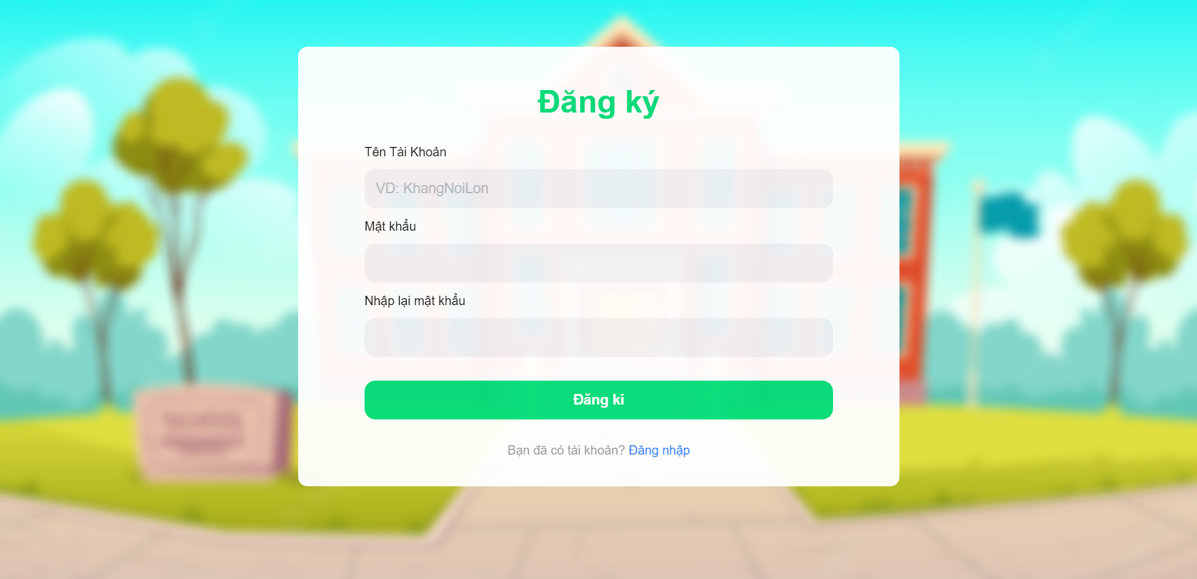

### b. Fill information:

* Function trigger: When user click “Đăng kí ” at home page and sign up success.
* Function description:

- Customer roles will have access to this screen.

- Show navigation bar: Home, class, ranking, payment, profile.

- User need to fill information which include: Full name, date of birth, gender, parent’s name, parent’s gmail, phone number to verify.

Screen layout:

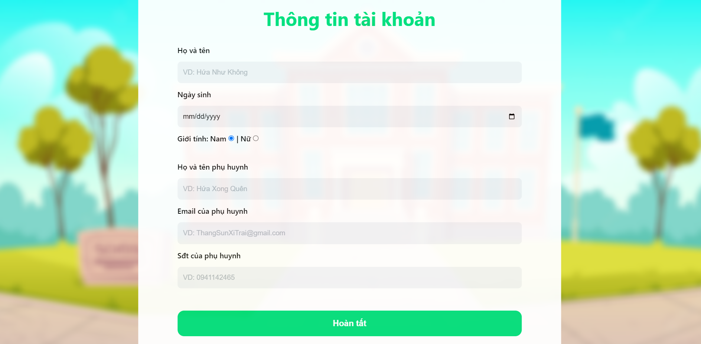

### c. Verify register:

* Function trigger: When user click “Đăng kí ” at home page, sign up and fill information success, user will receive code to verify email.
* Function description:

- Customer roles will have access to this screen.

- User receive number code in email and fill the code to verify account.

- The code will invalid after 2 minutes.

Screen layout:

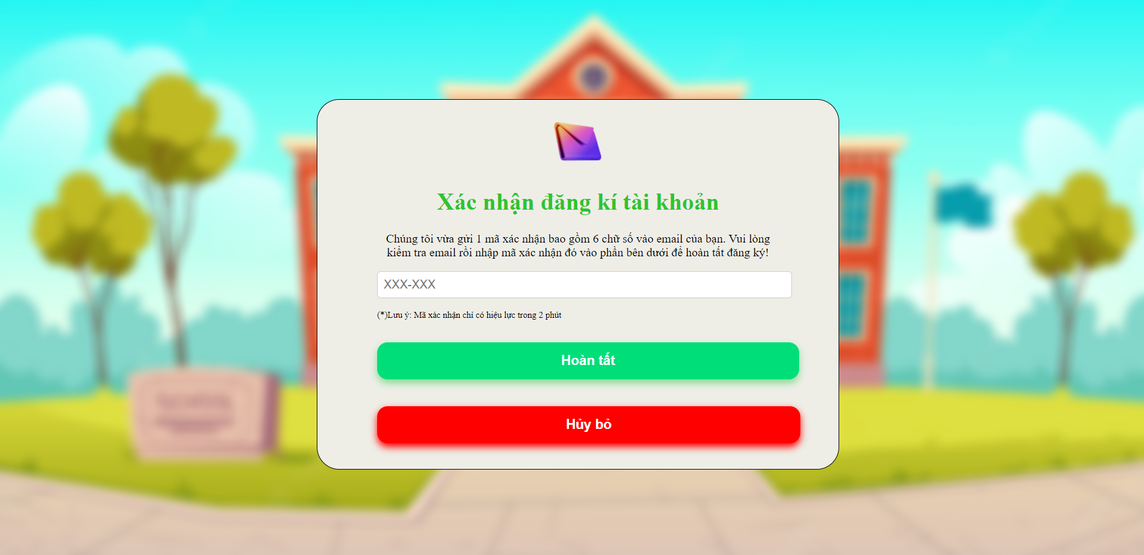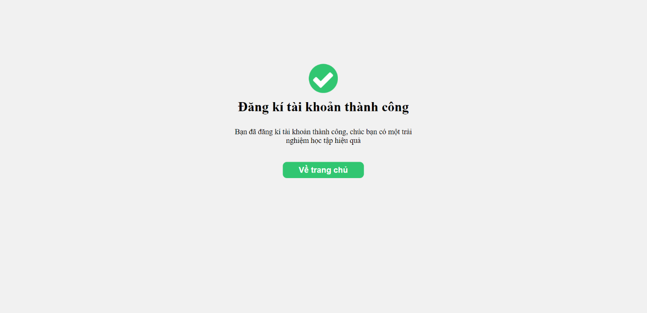

### d. Sign in:

* Function trigger: When user click “Đăng nhập” at home page.
* Function description:

- Customer roles will have access to this screen.

- Show navigation bar: Home, class, ranking, payment, profile.

- User need to fill their username and password to access their account.

Screen layout:

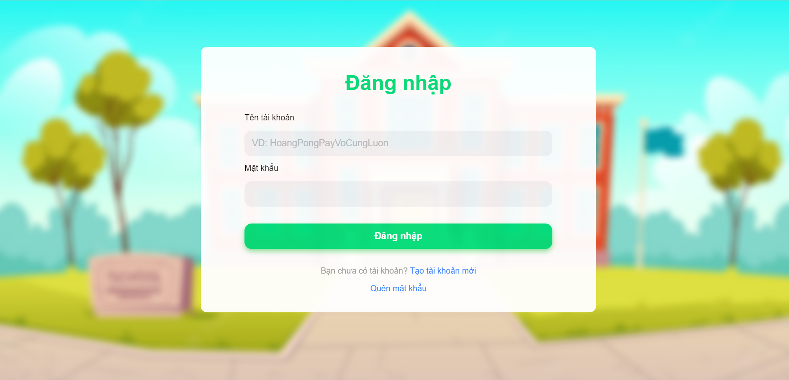

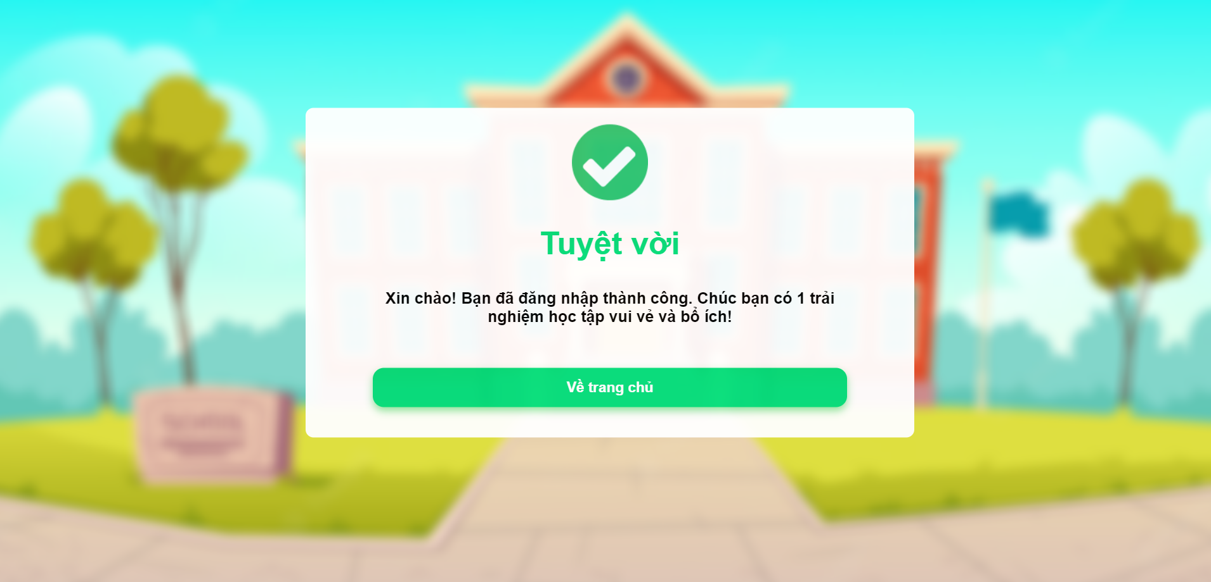

### e.Class:

* Function trigger: When user click to CLASS on navigation bar.
* Function description:

- Customer roles will have access to this screen.

- Show navigation bar: Home, class, ranking, payment, profile.

- Show all of the class from grade 1 to grade 5.

- User can choose the suitable class that they want to learn.

Screen layout:

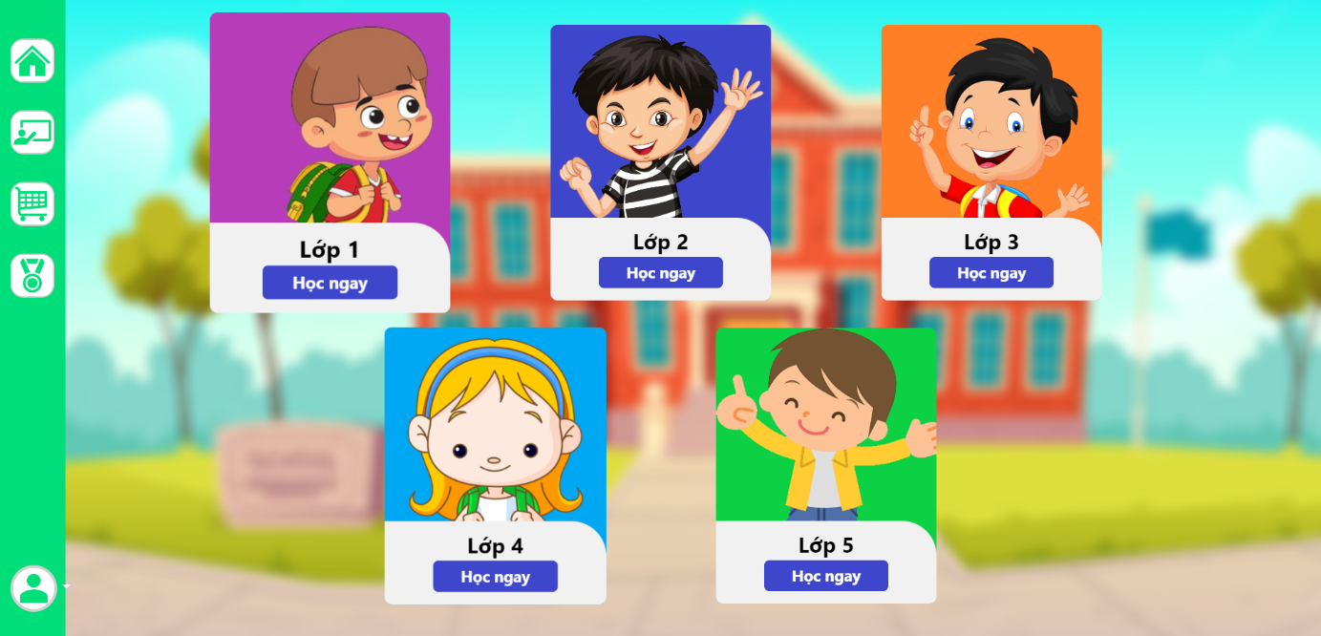

### f. Course:

* Function trigger: When user click to CLASS on navigation bar and choose their course they want .
* Function description:

- Customer roles will have access to this screen.

- Show navigation bar: Home, class, ranking, payment, profile.

- Show all of the course of the class (maths, literature, english).

- User can choose one of three subjects to learn.

Screen layout:

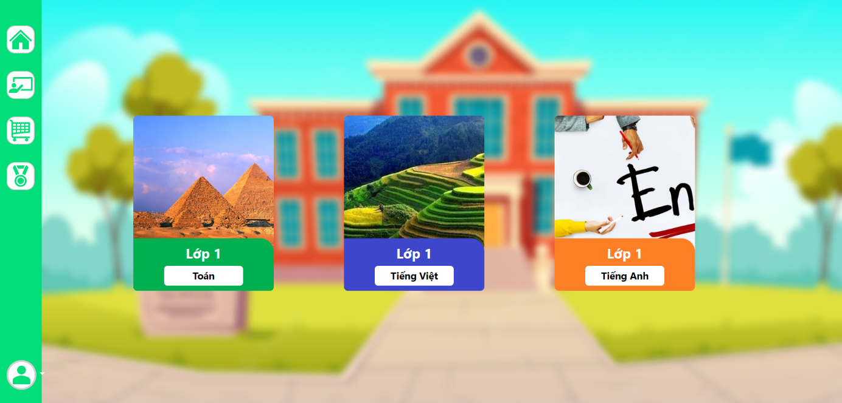

### g. Chapter:

* Function trigger: After choose course, user can choose chapter they want to learn.
* Function description:

- Customer roles will have access to this screen.

- Show navigation bar: Home, class, ranking, payment, profile.

- Show all chapter of subject that user can choose to learn.

- Show percent of learning of subject.

Screen layout:

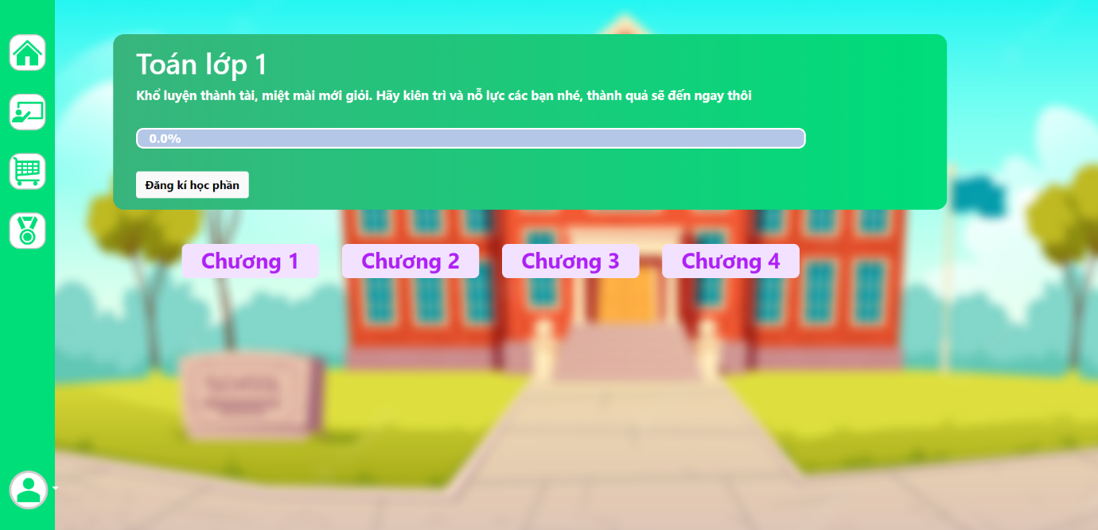

### h. Module:

* Function trigger: After choose chapter, user can choose module they want to learn.
* Function description:

- Customer roles will have access to this screen.

- Show navigation bar: Home, class, ranking, payment, profile.

- Show all module of chapter of subject that user can choose to learn.

- Show percent of learning this chapter of subject.

Screen layout:

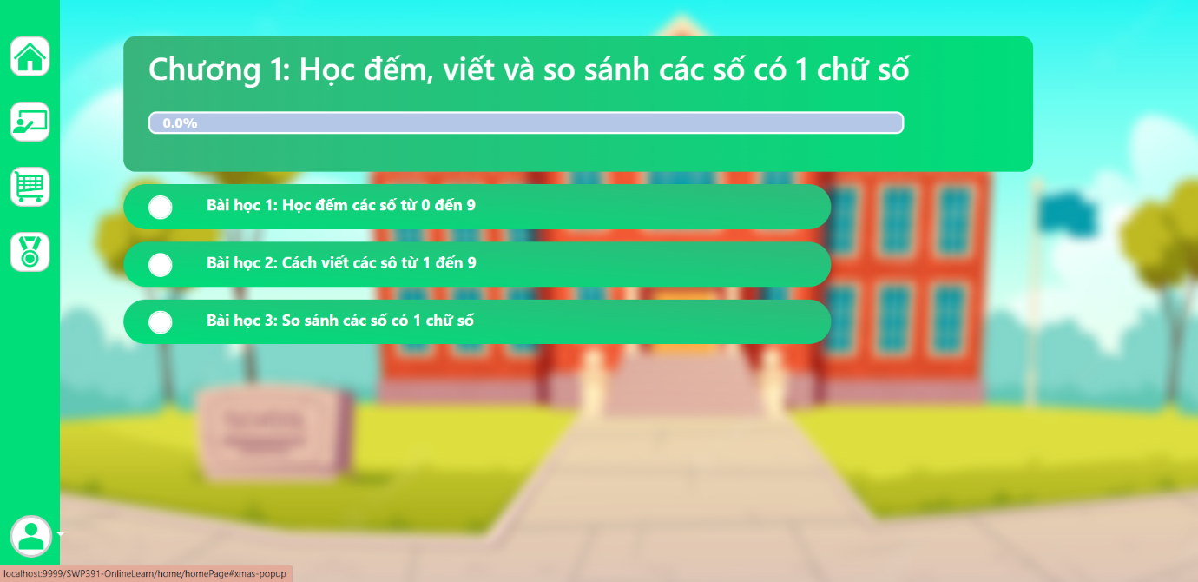

### i. Lession:

* Function trigger: After choose module, user can choose lession they want to learn.
* Function description:

- Customer roles will have access to this screen.

- Show navigation bar: Home, class, ranking, payment, profile.

- Show all of lesson which include: Exercises, game, video, theory.

Screen layout:

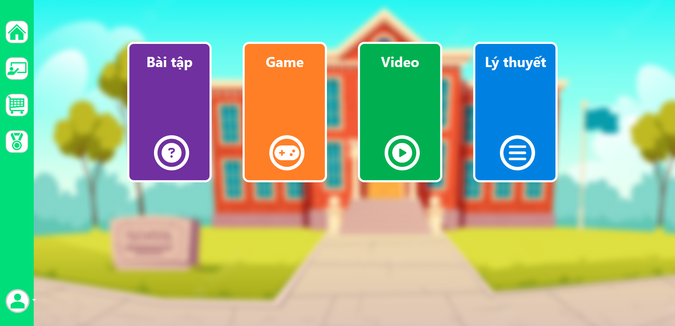

### j. Quiz:

* Function trigger: After choose lession, user can choose quiz to do.
* Function description:

- Customer roles will have access to this screen.

- Show navigation bar: Home, class, ranking, payment, profile.

- User can press to start excercises.

- User need to read and follow the rules of this excercises.

- User need to answer all of the questions to finish the excercises.

- User can re-do excercises.

- After doing quiz, user receive their point.

Screen layout:

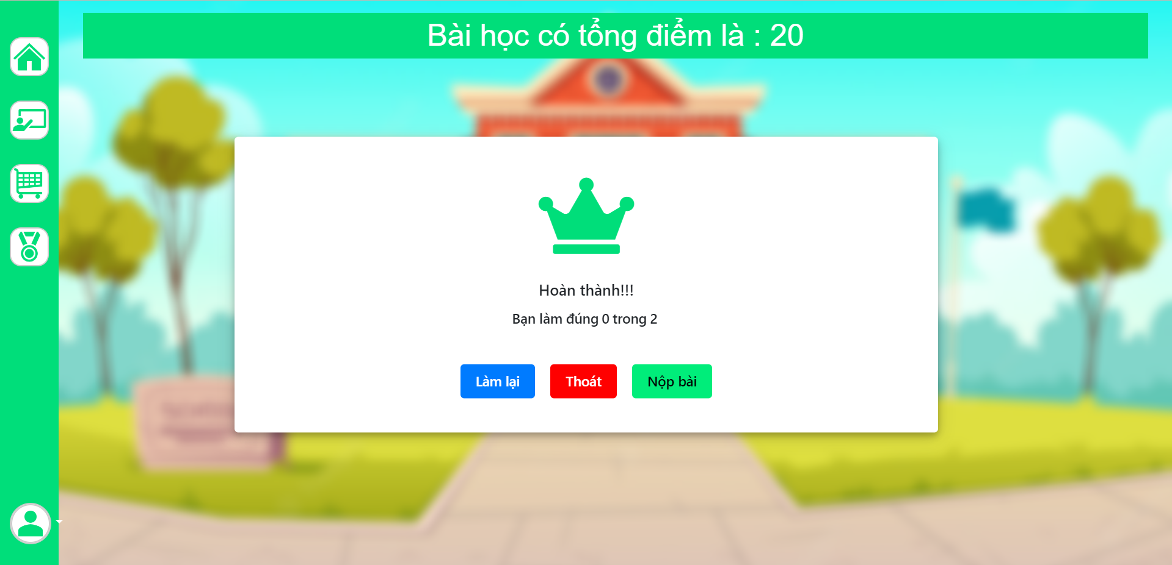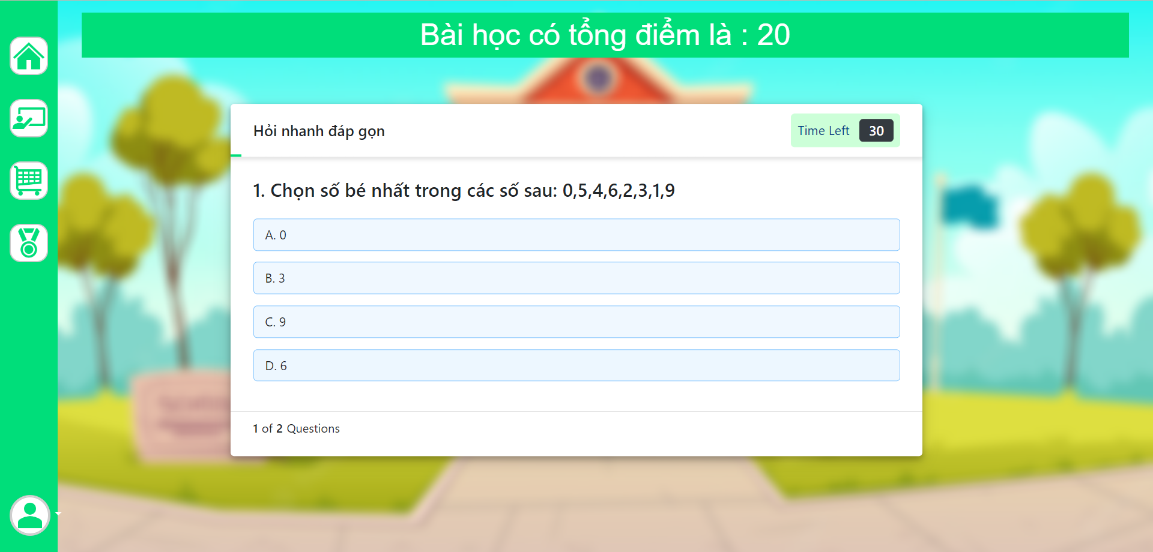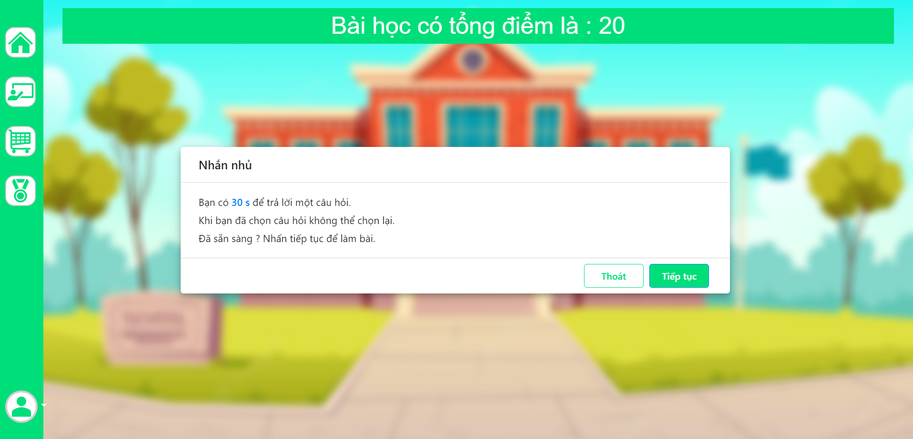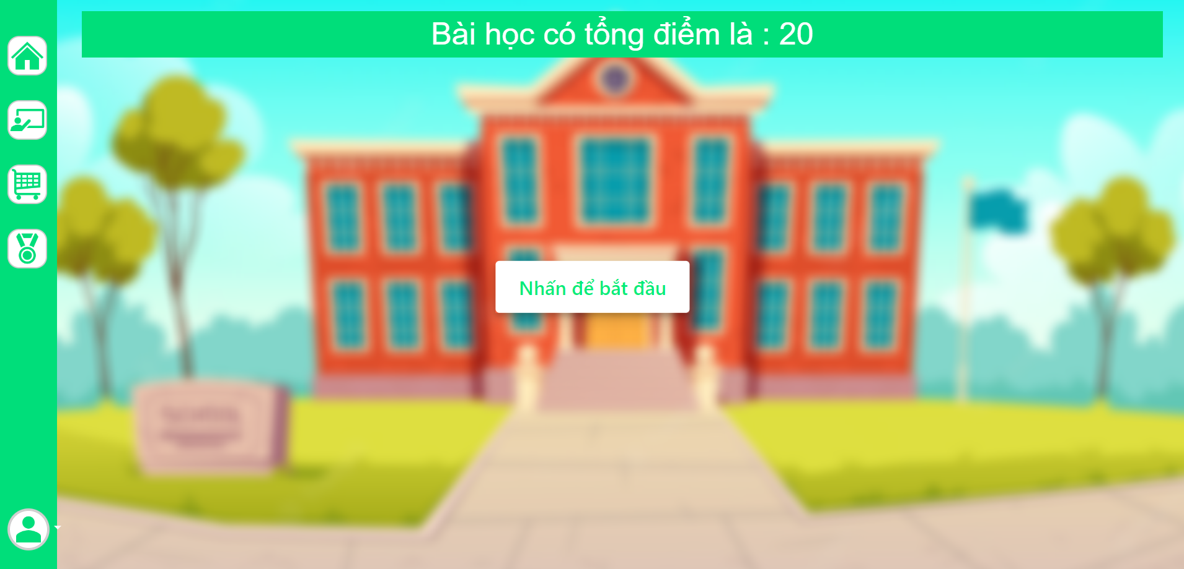

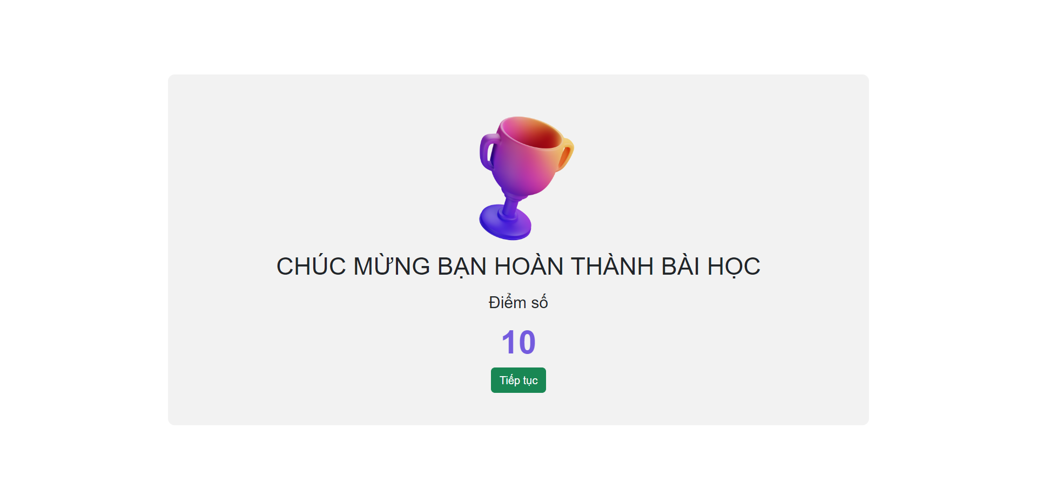

### k. Video lession:

* Function trigger: After choose lession, user can choose video lession to learn.
* Function description:

- Customer roles will have access to this screen.

- Show navigation bar: Home, class, ranking, payment, profile.

- Show video that user can watch to learn. After watching video, user can do excercises and play game.

Screen layout:

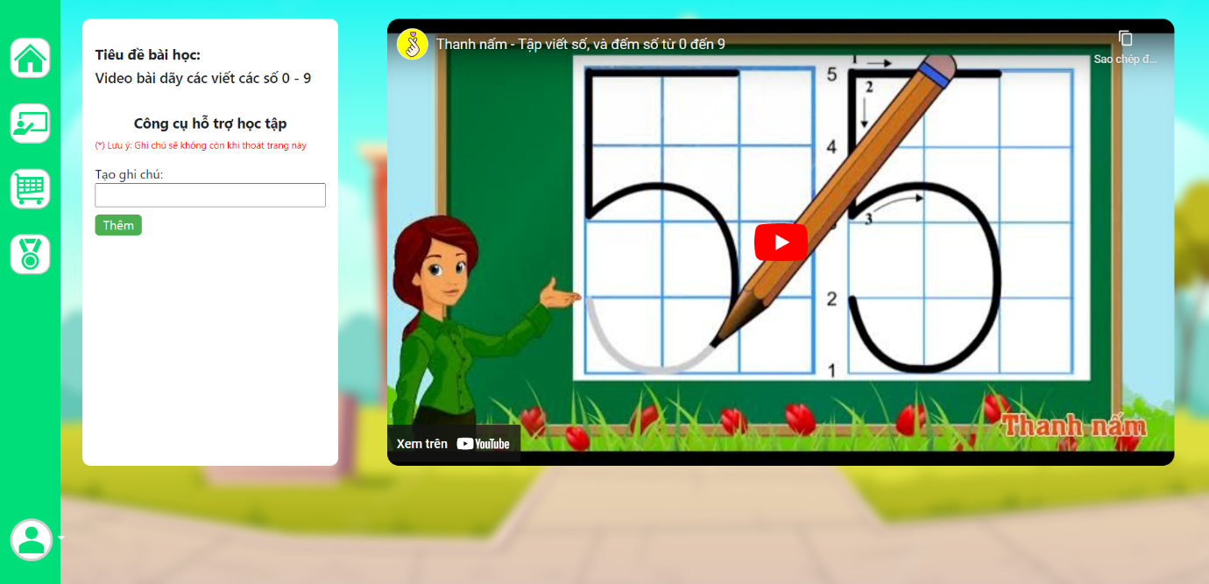

### l. Games:

* Function trigger: After choose lession, user can choose games to do.
* Function description:

- Customer roles will have access to this screen.

- Show navigation bar: Home, class, ranking, payment, profile.

- Press start to start playing game.

- Click image to right image to have point.

- After 100 second, the game will finish and caculate pointn you have.

Screen layout:

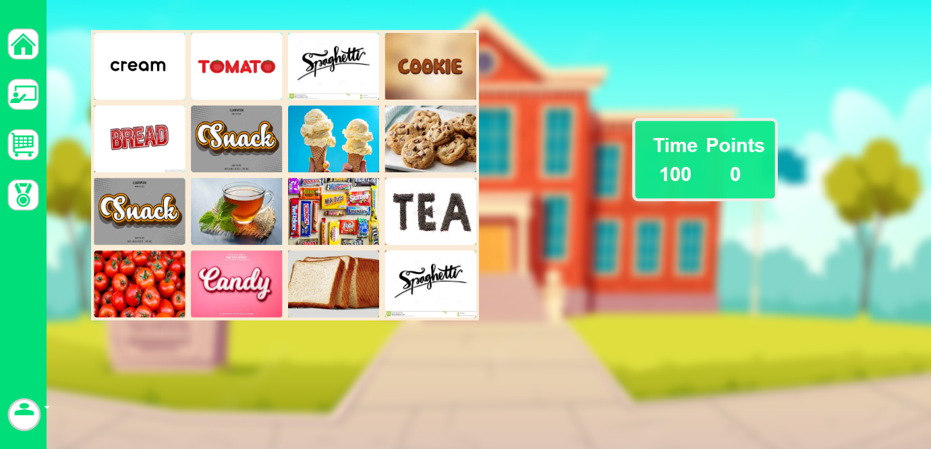

### m. Payment:

* Function trigger: When user click “Payment ” at navigation bar.
* Function description:

- Customer roles will have access to this screen.

- Show navigation bar: Home, class, ranking, payment, profile.

- Show transaction of user to pay for premium account which include visa, credit card, paypal.

- User need to fill the right number of their card.

- Show the advantages of premium account.

- Show the total price of premium account per year and VAT.

Screen layout:

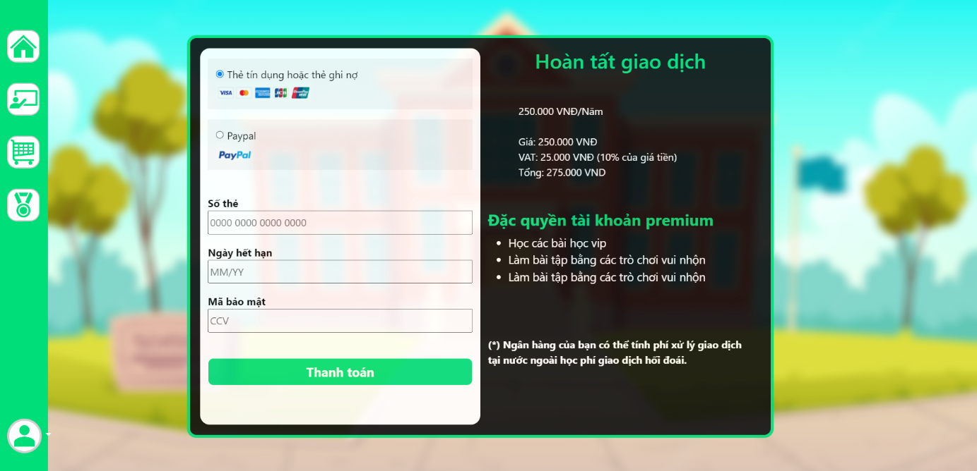

### n. Confirm payment:

* Function trigger: When user fill success payment, you will receive code in email.
* Function description:

- Customer roles will have access to this screen.

- This screen notifies to user to enter code which have 6 numbers. The code is in their email that we sent to.

-User need to fill the code in 2 minutes or the code will be expired.

Screen layout:

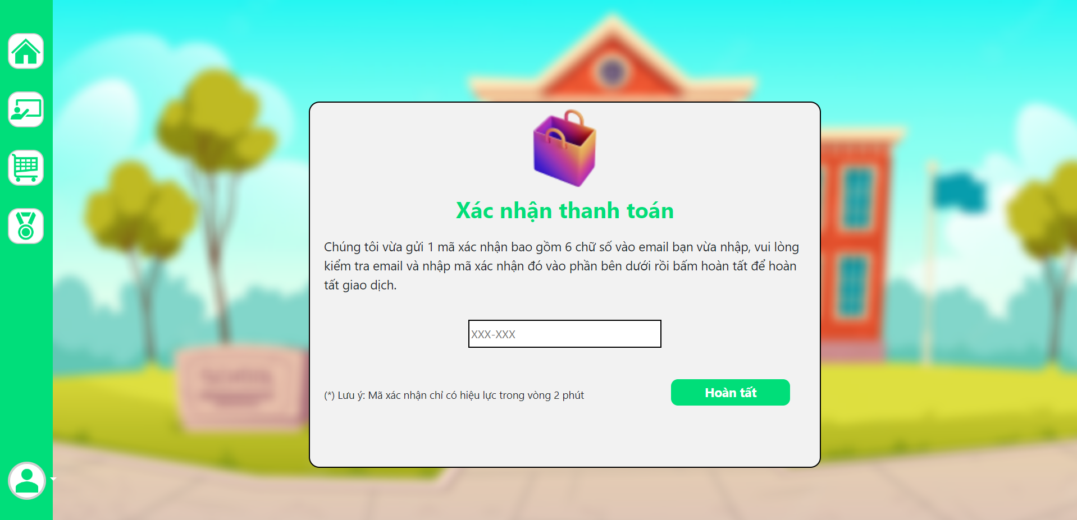

### o. Email payment:

* Function trigger: When user verify their payment.
* Function description:

- Customer roles will have access to this screen.

- This screen notifies to user that user have to fill email to confirm to pay

-User need to fill their email address and click to send code to pay.

Screen layout:

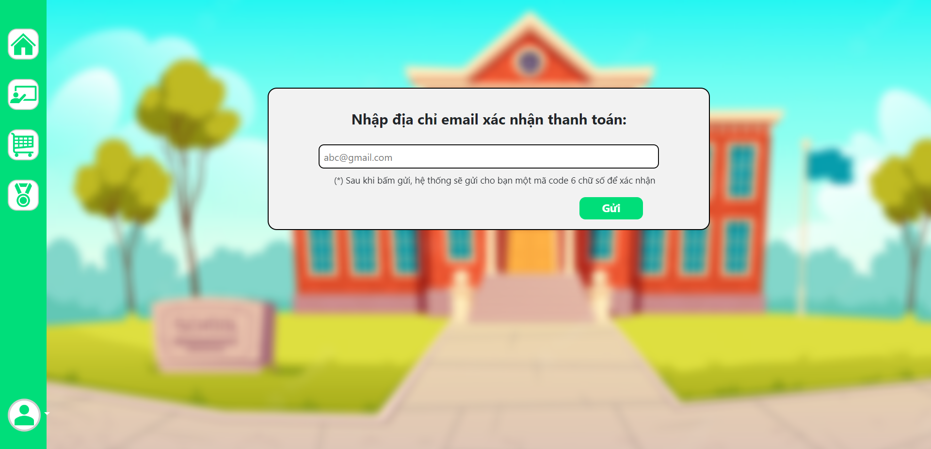

### p. User profile:

* Function trigger: When user click “Hồ sơ người dùng ” at home page.
* Function description:

- Customer roles will have access to this screen.

- Show navigation bar: Home, class, ranking, payment, profile.

- Show all information about user which include: Full name, date of birth, gender, parent’s name, parent’s email, phone number, user id, type of account.

Screen layout:



### q. Change user profile:

* Function trigger: When user click change user profile in user profile.
* Function description:

- Customer roles will have access to this screen.

- Show navigation bar: Home, class, ranking, payment, profile.

- User can change information which include: Full name, gender, date of birth, parent’s name, parent’s email, phone number, user id, type of account.

- User press save to save new information.

Screen layout:



### r. Change password:

* Function trigger: When user click “đổi mật khẩu” in user profile.
* Function description:

- Customer roles will have access to this screen.

- Show form which include old password, new password, confirm new password.

- User need to fill valid password.

Screen layout:

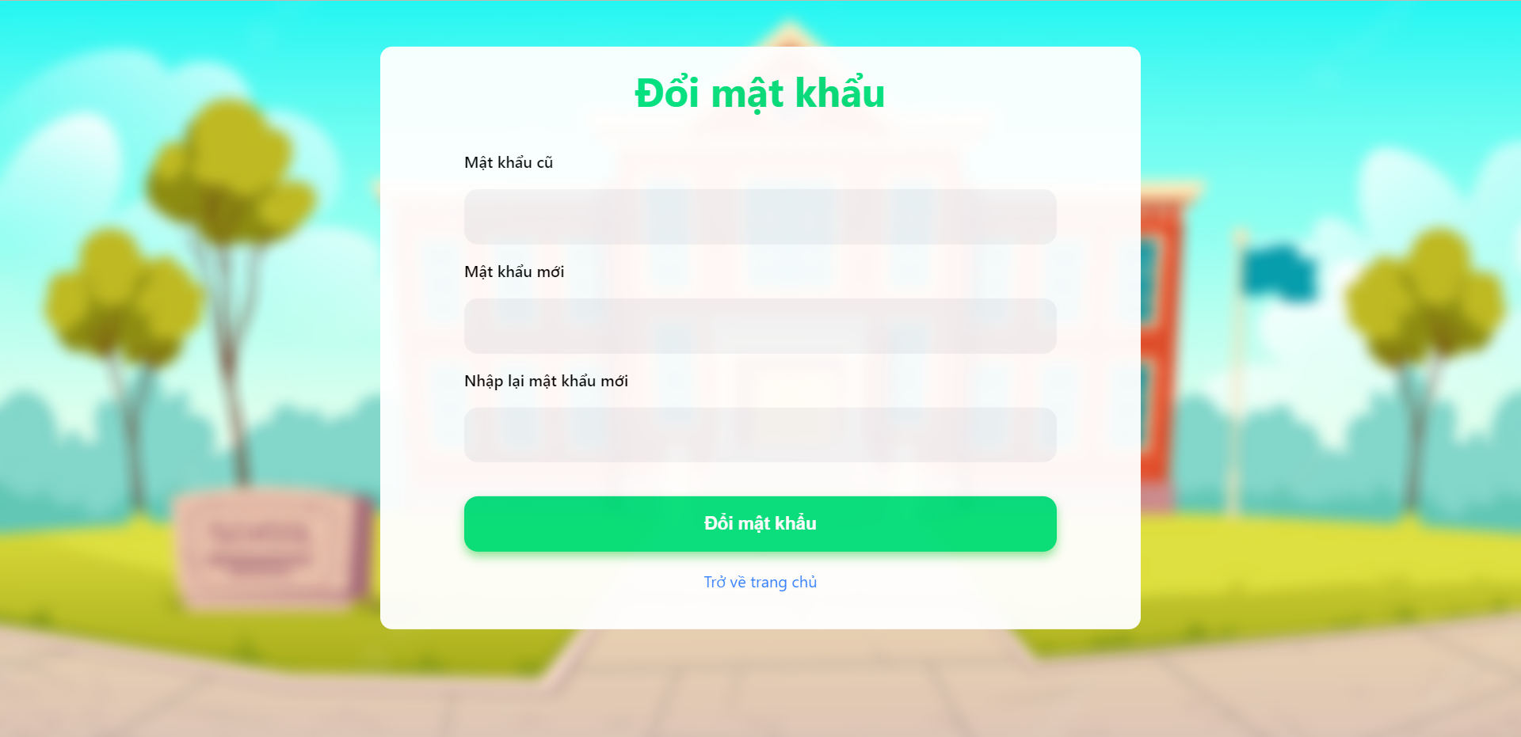

### s. Ranking:

* Function trigger: When user click “Ranking” at home page.
* Function description:

- Customer roles will have access to this screen.

- Show navigation bar: Home, class, ranking, payment, profile.

- Show ranking point, index.

- User can search by name to find their ranking and point.

Screen layout:



## 3. Admin feature:

### a. Manage quiz:

* Function trigger: When admin click manage quiz.
* Function description:

- Customer roles will have access to this screen.

- Show form which admin choose class, course, chapter, lession that admin want to add or delete quiz.

- After fill the form, admin press “Hoàn Tất” to add quiz.

- After choose question, admin press “Xác nhận và xóa” to delete quiz.

Screen layout:

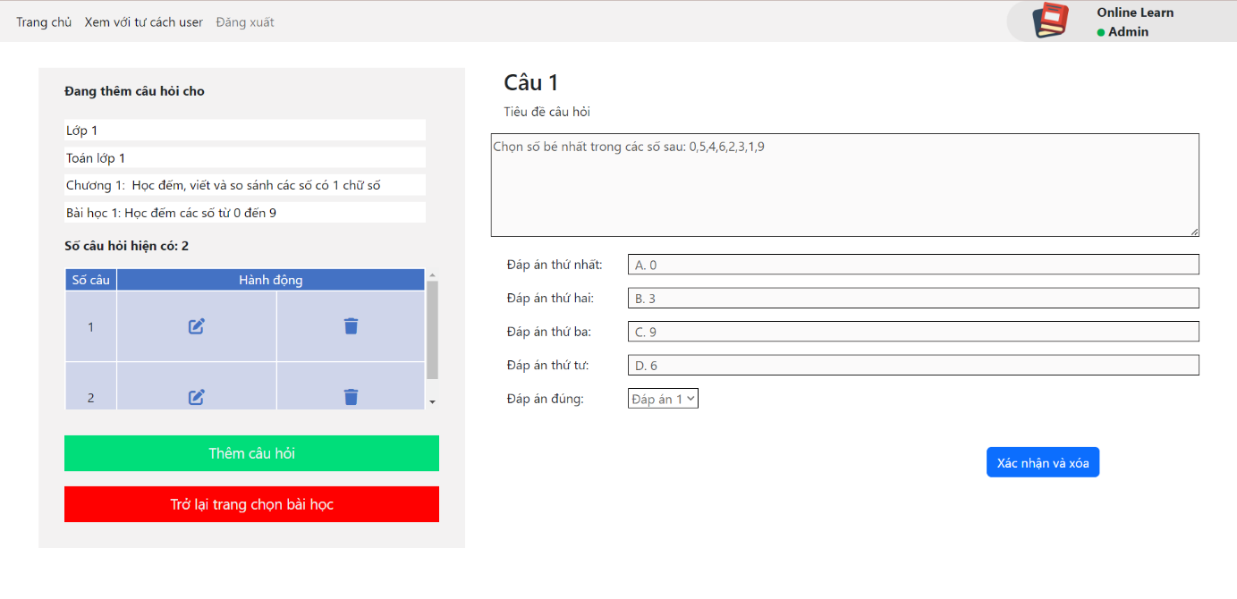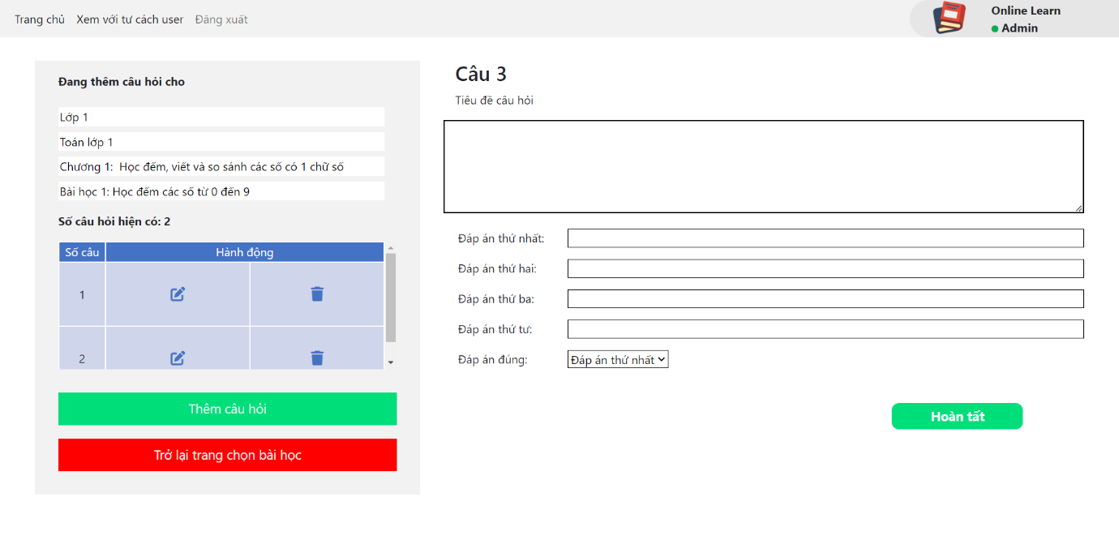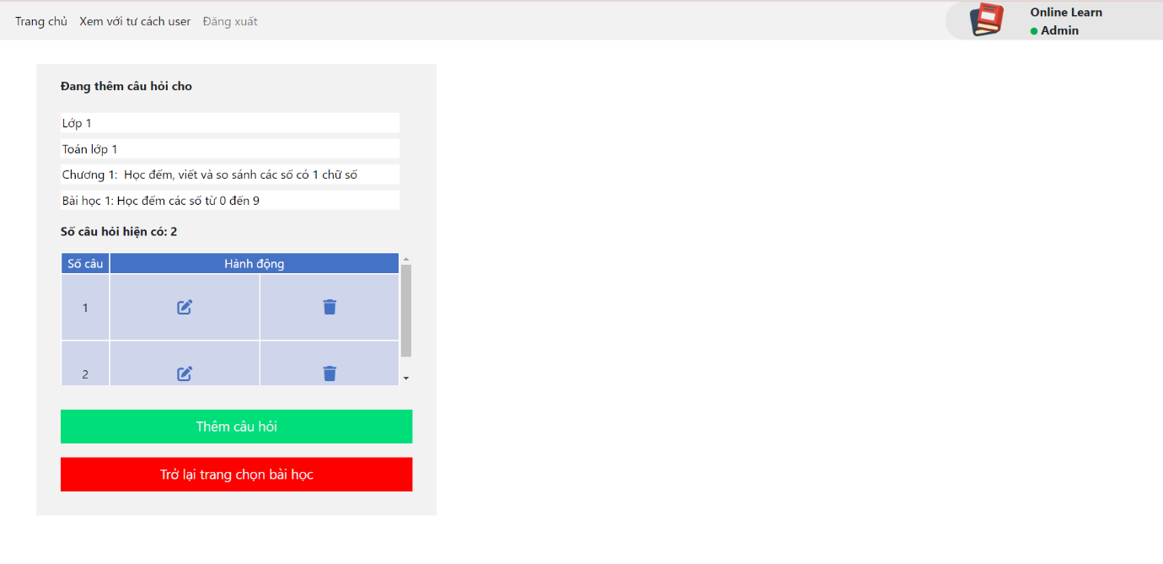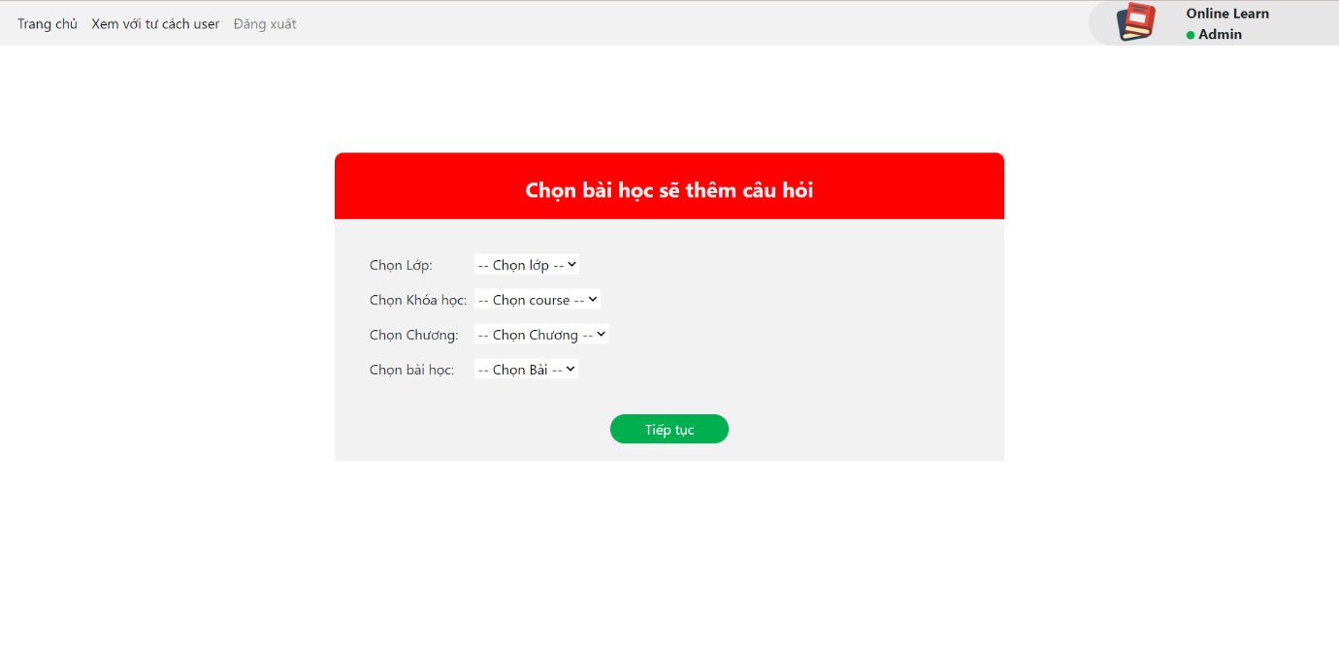

### b. Manage games:

* Function trigger: When admin click manage games.
* Function description:

- Customer roles will have access to this screen.

- Show form which admin choose class, course, chapter, lession that admin want to add pictures for game.

- After fill the form, admin press “Hoàn tất” to add pictures.

Screen layout:

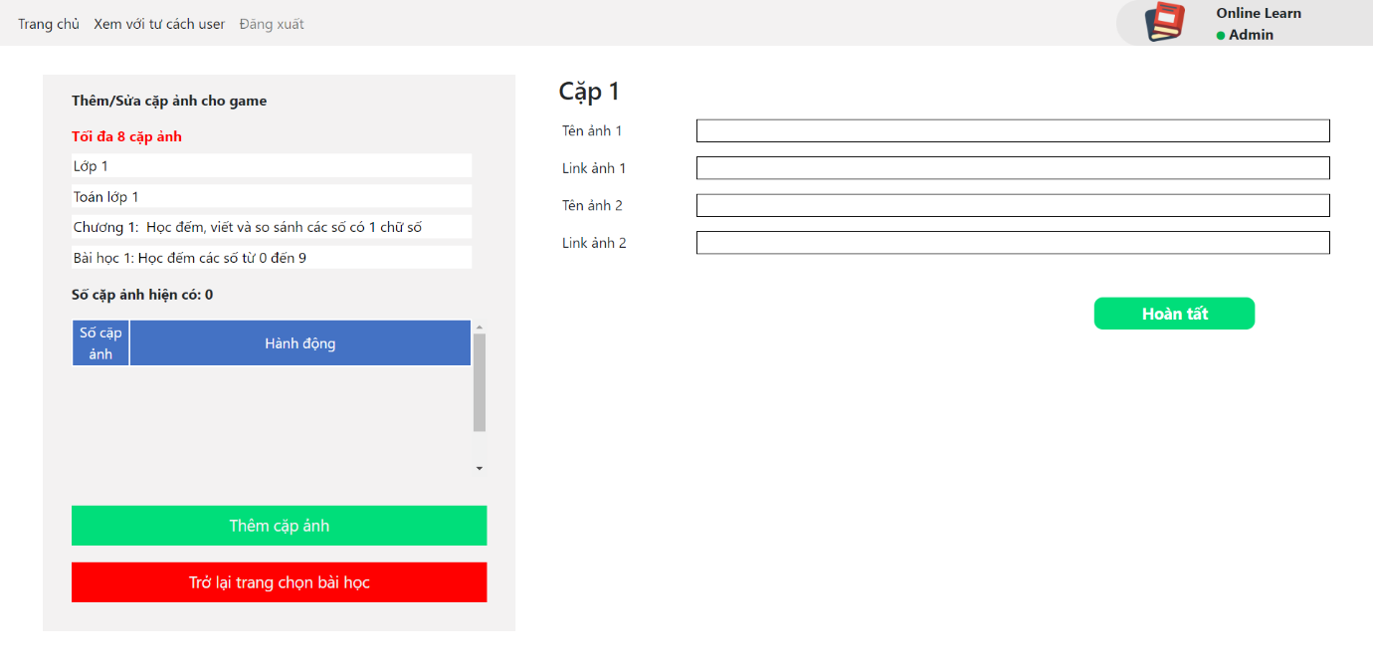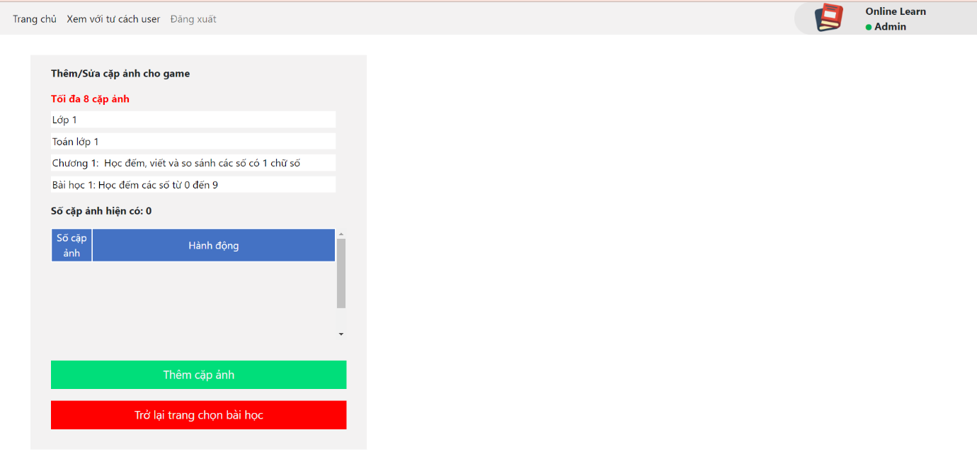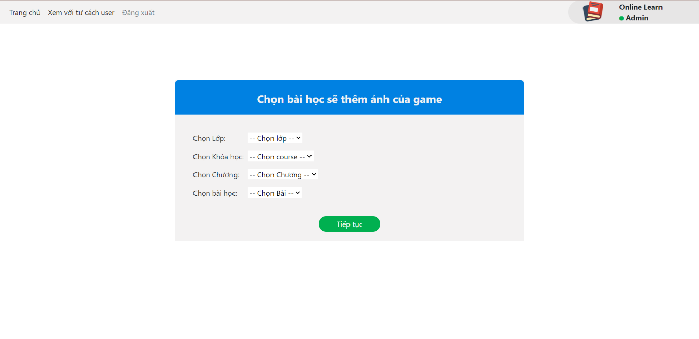

### c. Manage video lession:

* Function trigger: When admin click manage video lession.
* Function description:

- Customer roles will have access to this screen.

- Show form which admin choose class, course, chapter, lession that admin want to add or delete quiz.

- After fill the form, admin press “Hoàn Tất” to add quiz.

- After choose question, admin press “Xác nhận và xóa” to delete quiz.Screen layout:

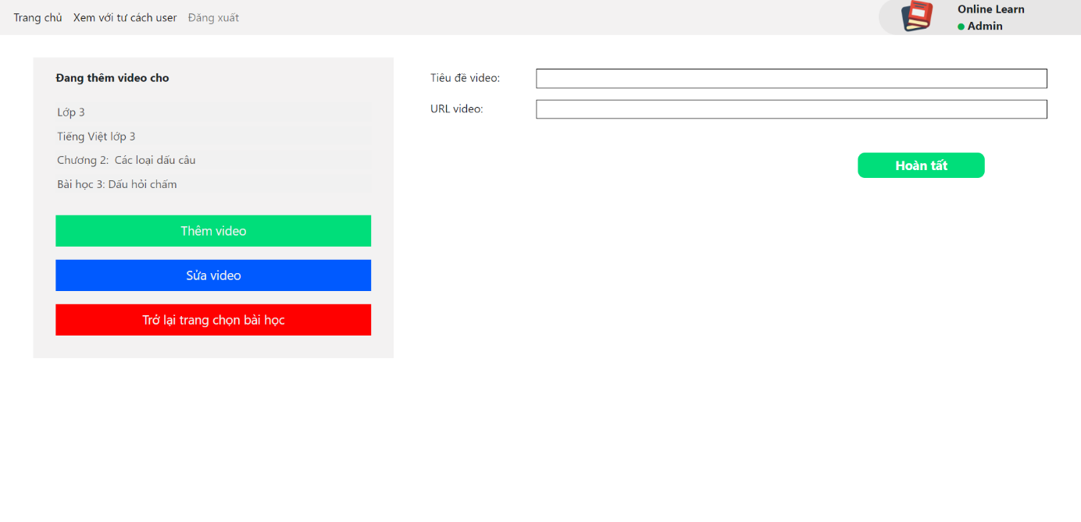

### d. Manage content:

* Function trigger: When admin click manage content.
* Function description:

- Customer roles will have access to this screen.

- Show form which admin choose class, course, chapter, lession that admin want to add/edit content.

- After fill the form, admin press “Hoàn tất” to add content or edit content.

Screen layout:

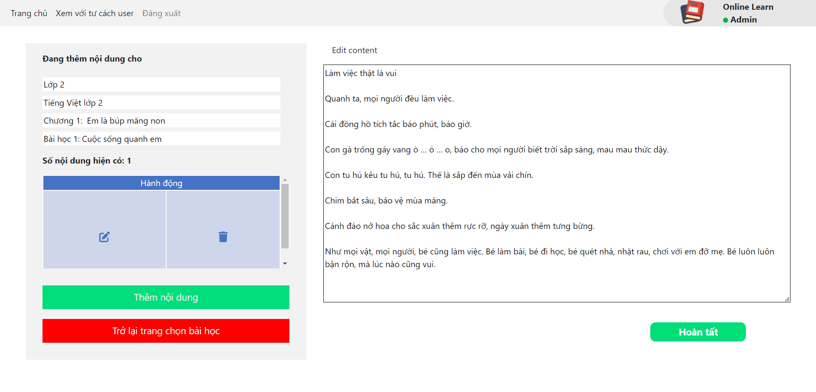

### e. Manage user:

* Function trigger: When admin click manage user.
* Function description:

- Customer roles will have access to this screen.

- Show total account which include normal account and premium account.

- Show list of account information which include: Full name, date of birth, gender, parent’s full name, parent’s email, parent’s phone number and usernamme.

- Admin can search by name account.

Screen layout:

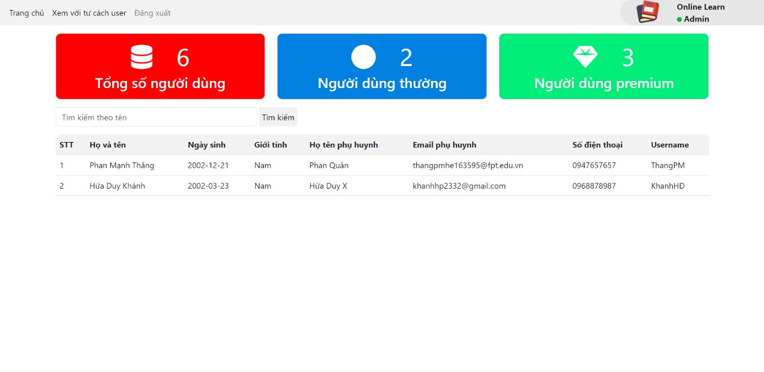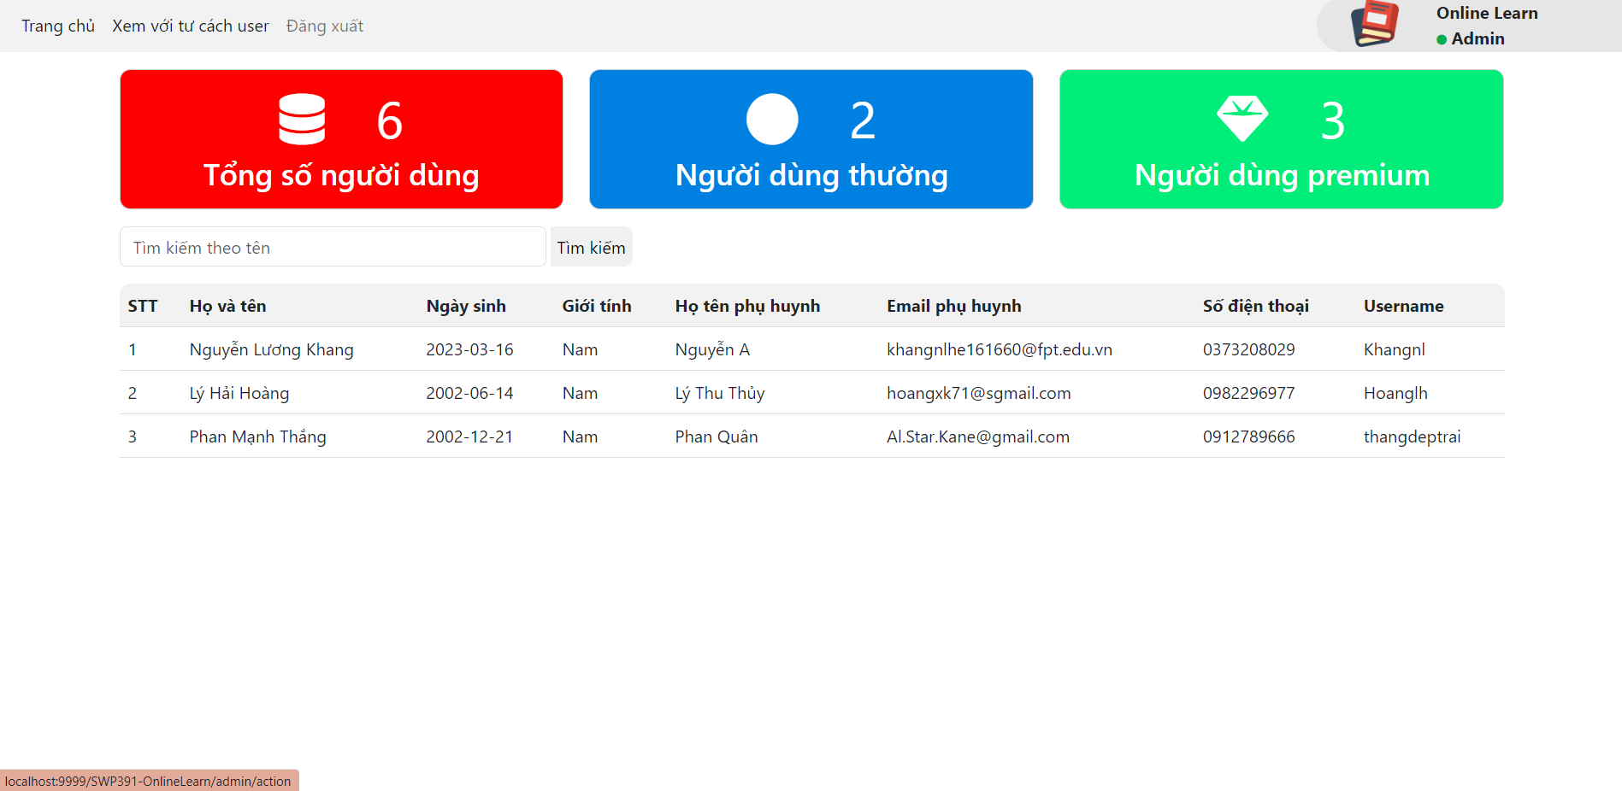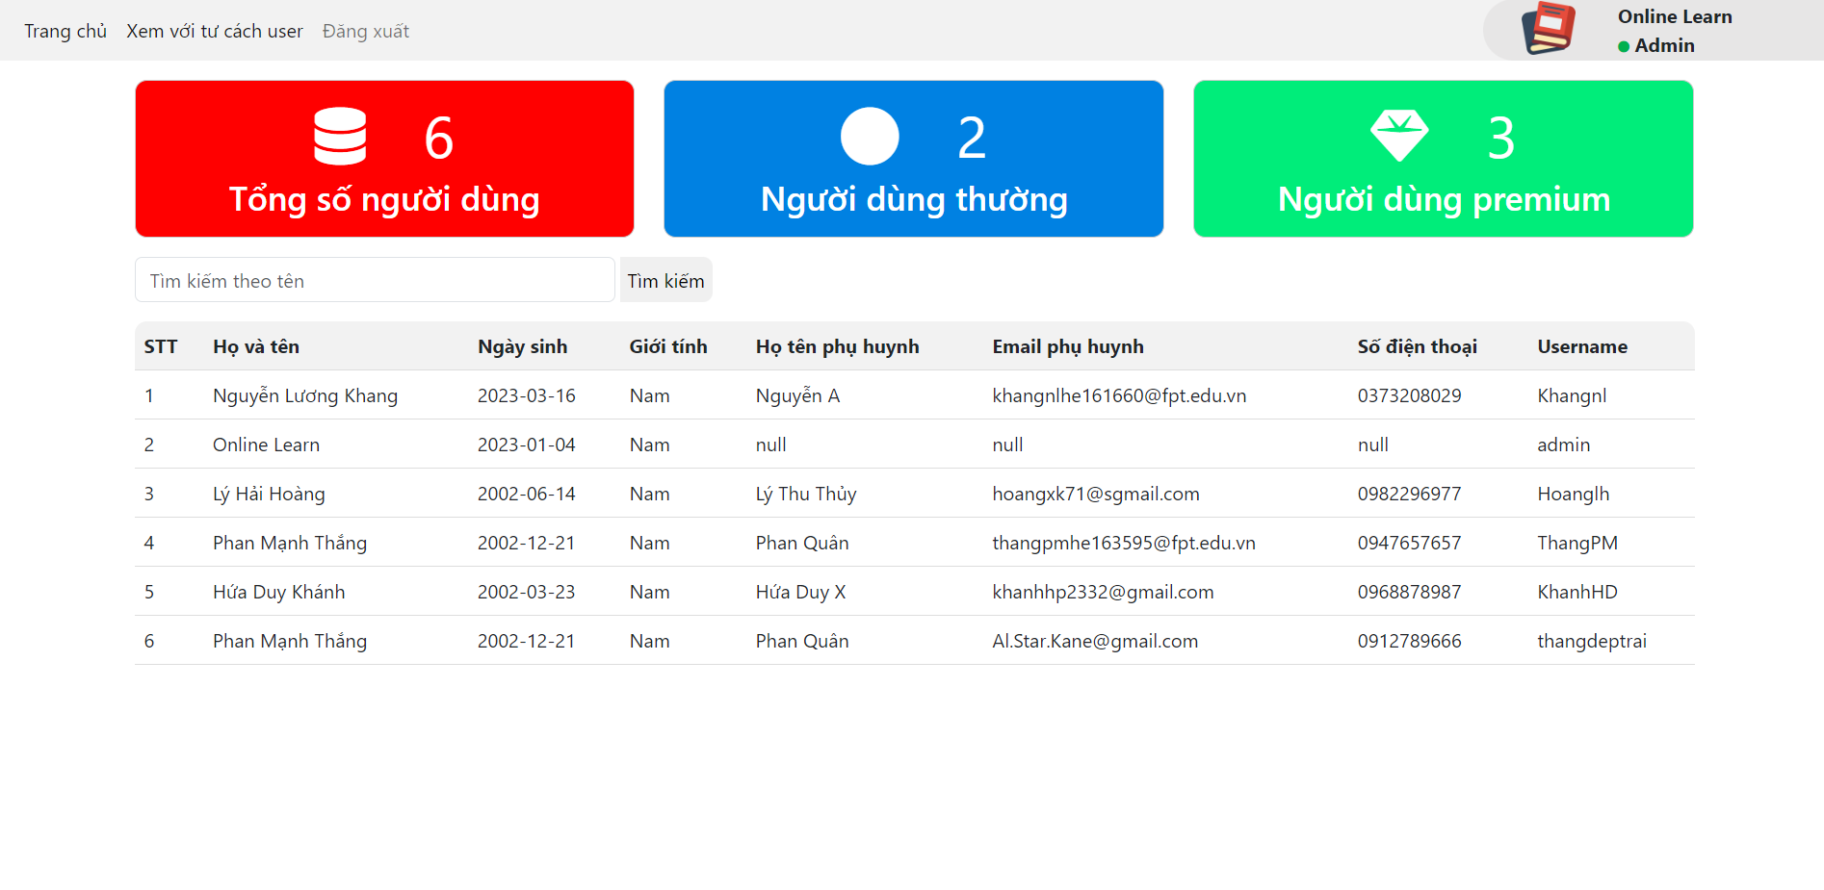

### f. Add/modify chapter:

* Function trigger: When admin click add/modify chapter:
* Function description:

- Customer roles will have access to this screen.

- Show form which admin choose class, course, chapter that admin want to add or modify chapter.

- After fill the form, admin press “Hoàn tất” to add or modify chapter.Screen layout:

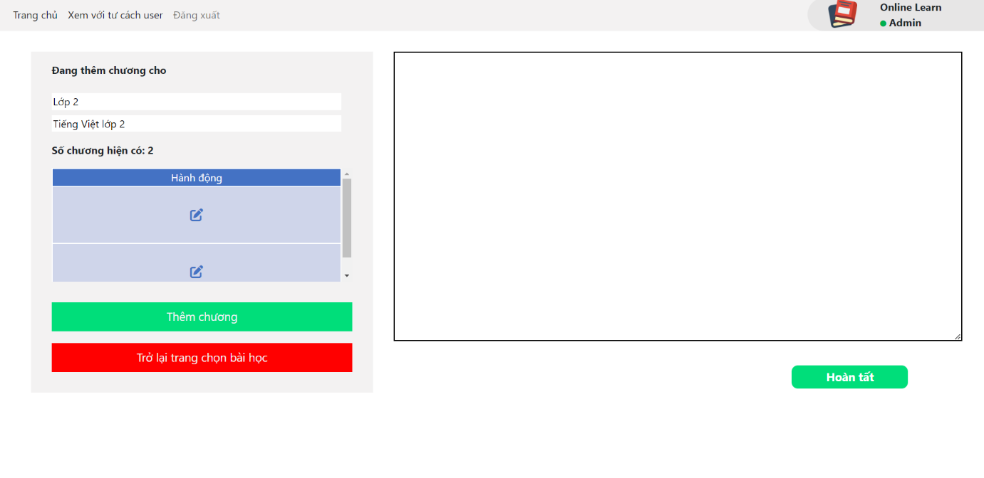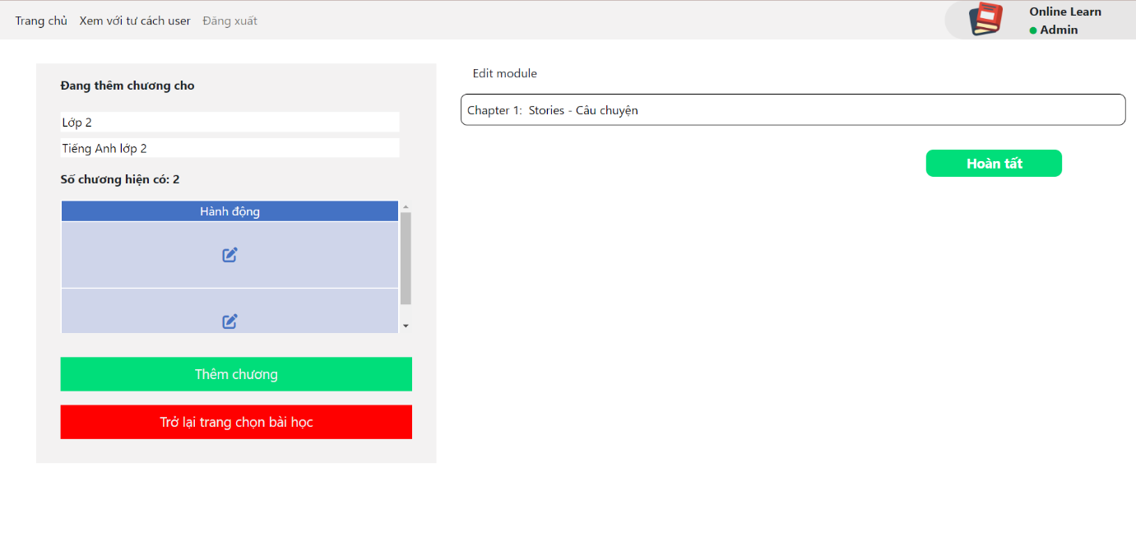

### g. Add/modify lession:

* Function trigger: When admin click add/modify lession
* Function description:

- Customer roles will have access to this screen.

- Show form which admin choose class, course, chapter that admin want to add or modify module.  
- After fill the form, admin press “Hoàn tất” to add or modify module.Screen layout:

